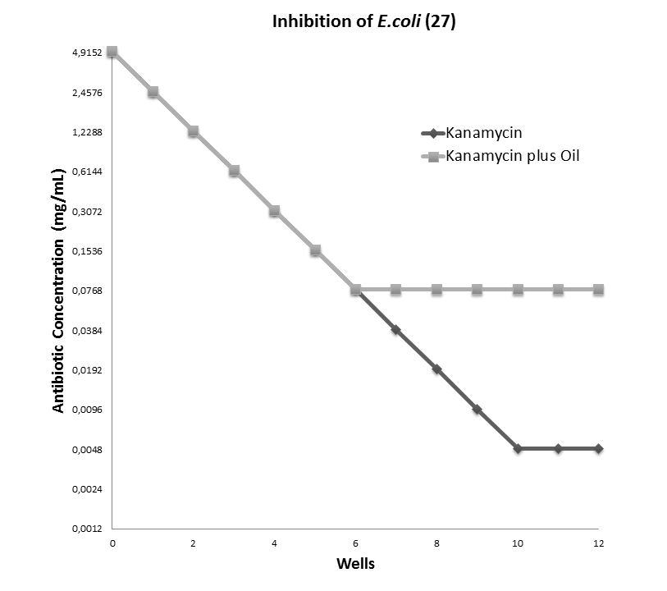

Figure 2. Determination of minimum inhibitory concentration of kanamycin against E. coli 27 and its modulation by B. virgilioides oil at 64 µg/mL.

