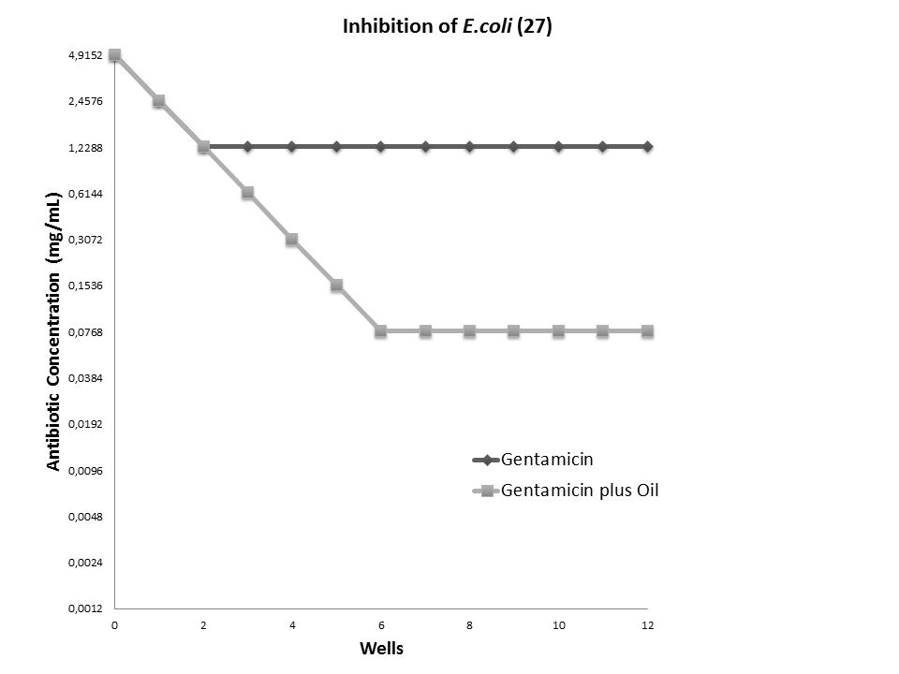

Figure 3. Determination of minimum inhibitory concentration of gentamcin against E. coli 27 and its modulation by B. virgilioides oil at 64 µg/mL.

