Figure legend
Figure 1. Map showing the two study sites in the Brazilian state of Sergipe.
Figure 2. Number of individuals in each height class (intervals of 3 m) at the FT (Fazenda Trapsa) and MJ (Mata do Junco Wildlife Refuge) in Sergipe, Brazil.

Figures

Figure 1.
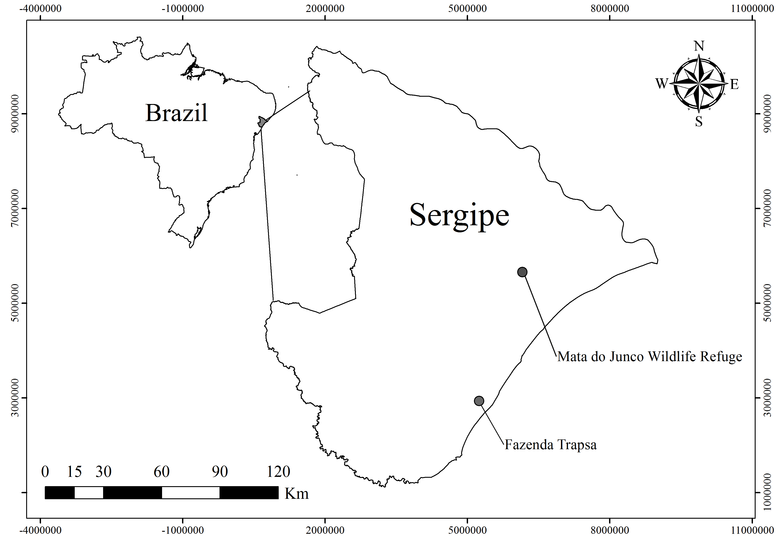

Figure 2.

Tables

Table 1. Phytosociological parameters of sampled tree species at the Fazenda Trapsa, Itaporanga d’ajuda, and Mata do Junco Wildlife Refuge, Capela, Sergipe, Brazil, arranged by decreasing IVI. (AbsDe = absolute density (ind./ha⁻¹); RelDe = relative density (%); AbsFr = absolute frequency; RelFr = relative frequency (%); AbsDo = absolute dominance (m²/ha⁻¹); RelDo = relative dominance; IVI = importance value index).
Species | AbsDe | RelDe | AbsFr | RelFr | AbsDo | RelDo | IVI
Fazenda Trapsa
Eschweilera ovata (Cambess.) Mart. ex Miers | 330.00 | 25.38 | 90 | 16.67 | 1.91 | 12.99 | 55.04
Tapirira guianensis Aubl. | 80.00 | 6.15 | 50 | 9.26 | 4.48 | 30.39 | 45.80
Poecilanthe parviflora Benth. | 230.0 | 17.69 | 60 | 11.11 | 1.37 | 9.32 | 38.13
Inga capitata Desv. | 130.0 | 10.00 | 50 | 9.26 | 1.52 | 10.33 | 29.59
Guettarda virbunoides Cham. & Schltdl. | 120.0 | 9.23 | 60 | 11.11 | 1.28 | 8.71 | 29.06
Pogonophora schomburgkiana Miers. ex Benth. | 110.0 | 8.46 | 70 | 12.96 | 0.39 | 2.62 | 24.05
Manilkara salzmannii (A.DC.) H.J.Lam | 60.00 | 4.62 | 40 | 7.41 | 1.21 | 8.23 | 20.25
Stryphnodendron pulcherrium (Willd.) Hochr. | 50.00 | 3.85 | 50 | 9.26 | 1.04 | 7.03 | 20.14
Pouteria bangii (Rusby) T.D.Penn. | 80.00 | 6.15 | 60 | 11.11 | 0.30 | 2.06 | 19.33
Attalea cf. funifera Mart. | 110.0 | 8.46 | 10 | 1.85 | 1.22 | 8.30 | 18.61
 | 1300.0 | 100 | 540 | 100 | 14.72 | 100 | 300.0
Mata do Junco Wildlife Refuge
Eschweilera ovata ovata (Cambess.) Mart. ex Miers | 210.0 | 25.61 | 60 | 13.95 | 3.35 | 20.70 | 60.26
Luehea ochrophylla Mart. | 20.00 | 2.44 | 10 | 2.33 | 5.21 | 32.18 | 36.95
Ocotea canaliculata (Rich.) Mez | 80.00 | 9.76 | 50 | 11.63 | 1.84 | 11.38 | 32.76
Pouteria bangii (Rusby) T.D.Penn. | 110.0 | 13.41 | 50 | 11.63 | 1.20 | 7.40 | 32.45
Byrsonima sericea DC. | 50.00 | 6.10 | 40 | 9.30 | 1.82 | 11.23 | 26.63
Campomanesia dichotoma (O.Berg.) Mattos | 70.00 | 8.54 | 40 | 9.30 | 1.32 | 8.18 | 26.01
Protium heptaphyllum (Aubl.) Marchand | 70.00 | 8.54 | 60 | 13.95 | 0.27 | 1.66 | 24.15
Erythroxylum squamatum Sw. | 90.00 | 10.98 | 40 | 9.30 | 0.33 | 2.05 | 22.33
Schefflera morototoni (Aubl.) Maguire et al. | 50.00 | 6.10 | 50 | 11.63 | 0.56 | 3.45 | 21.18
Miconia prasina (Sw.) DC. | 70.00 | 8.54 | 30 | 6.98 | 0.29 | 1.77 | 17.28
 | 820.0 | 100 | 430 | 100 | 16.19 | 100 | 300.0

Table 2. Phytosociological parameters of sampled tree families at the Fazenda Trapsa, Itaporanga d’ajuda, and Mata do Junco Wildlife Refuge, Capela, Sergipe, Brazil, arranged by decreasing IVI. (AbsDe = absolute density (ind./ha⁻¹); RelDe = relative density (%); AbsFr = absolute frequency; RelFr = relative frequency (%); AbsDo = absolute dominance (m²/ha⁻¹); RelDo = relative dominance; IVI = importance value index).
Family | AbsDe | RelDe | AbsFr | RelFr | AbsDo | RelDo | IVI
Fazenda Trapsa
Fabaceae | 410.0 | 31.54 | 80 | 18.60 | 3.93 | 26.69 | 76.83
Lecythidaceae | 330.0 | 25.38 | 90 | 20.93 | 1.91 | 12.99 | 59.31
Anacardiaceae | 80.0 | 6.15 | 50 | 11.63 | 4.48 | 30.39 | 48.17
Sapotaceae | 140.0 | 10.77 | 70 | 16.28 | 1.52 | 10.29 | 37.34
Rubiaceae | 120.0 | 9.23 | 60 | 13.95 | 1.28 | 8.71 | 31.90
Peraceae | 110.0 | 8.46 | 70 | 16.28 | 0.39 | 2.62 | 27.36
Arecaceae | 110.0 | 8.46 | 10 | 2.33 | 1.22 | 8.30 | 19.09
 | 1300.0 | 100 | 430 | 100 | 14.73 | 100.0 | 300.0
Mata do Junco Wildlife Refuge
Lecythidaceae | 210.0 | 25.61 | 60 | 13.95 | 3.35 | 20.70 | 60.26
Malvaceae | 20.0 | 2.44 | 10 | 2.33 | 5.21 | 32.18 | 36.95
Lauraceae | 80.0 | 9.76 | 50 | 11.63 | 1.84 | 11.38 | 32.76
Sapotaceae | 110.0 | 13.41 | 50 | 11.63 | 1.20 | 7.40 | 32.45
Malpighiaceae | 50.0 | 6.10 | 40 | 9.30 | 1.82 | 11.23 | 26.63
Myrtaceae | 70.0 | 8.54 | 40 | 9.30 | 1.32 | 8.18 | 26.01
Burseraceae | 70.0 | 8.54 | 60 | 13.95 | 0.27 | 1.66 | 24.15
Erythroxylaceae | 90.0 | 10.98 | 40 | 9.30 | 0.33 | 2.05 | 22.33
Araliaceae | 50.0 | 6.10 | 50 | 11.63 | 0.56 | 3.45 | 21.18
Melastomataceae | 70.0 | 8.54 | 30 | 6.98 | 0.29 | 1.77 | 17.28
 | 820.0 | 100 | 430 | 100 | 16.19 | 100 | 300.0

Table 3. Phytosociological parameters of sampled liana species at the Fazenda Trapsa, Itaporanga d’Ajuda, and Mata do Junco Wildlife Refuge, Capela, Sergipe, Brazil, arranged by decreasing IVI. (AbsDe = absolute density (ind./ha⁻¹); RelDe = relative density (%); AbsFr = absolute frequency; RelFr = relative frequency (%); AbsDo = absolute dominance (m²/ha⁻¹); RelDo = relative dominance; IVI = importance value index).
Species | AbsDe | RelDe | AbsFr | RelFr | AbsDo | RelDo | IVI
Fazenda Trapsa
Adenocalymma comosum (Cham.) DC. | 420.0 | 44.68 | 90 | 22.50 | 0.04 | 26.54 | 93.72
Coccoloba lucidula Benth. | 150.0 | 15.96 | 40 | 10.00 | 0.03 | 21.41 | 47.37
Coccoloba laevis Benth. | 50.00 | 5.32 | 20 | 5.00 | 0.02 | 11.86 | 22.18
Coccoloba parimensis Benth. | 30.00 | 3.19 | 30 | 7.50 | 0.01 | 7.64 | 18.33
Davilla kunthii A.St.-Hill | 50.00 | 5.32 | 30 | 7.50 | 0.01 | 4.64 | 17.46
Cissus sp. | 30.00 | 3.19 | 30 | 7.50 | 0.01 | 3.99 | 14.69
Bonamia burchellii (Choisy) Hallier f. | 30.00 | 3.19 | 30 | 7.50 | 0.00 | 1.46 | 12.16
Sparattanthelium botocudorum Mart. | 20.00 | 2.13 | 10 | 2.50 | 0.01 | 7.05 | 11.68
Coccoloba paraensis Benth. | 30.00 | 3.19 | 10 | 2.50 | 0.01 | 3.25 | 8.94
Phanera outimouta (Aubl.) L.P.Queiroz | 20.00 | 2.13 | 10 | 2.50 | 0.01 | 3.29 | 7.91
Heteropterys nordestina Amorim | 20.00 | 2.13 | 10 | 2.50 | 0.00 | 1.41 | 6.03
Morphotype 10 | 10.00 | 1.06 | 10 | 2.50 | 0.00 | 2.36 | 5.93
Strychnos cf. bahiensis Krukoff & Barneby | 10.00 | 1.06 | 10 | 2.50 | 0.00 | 1.25 | 4.81
Bonamia maripoides Hallier f. | 10.00 | 1.06 | 10 | 2.50 | 0.00 | 0.70 | 4.27
Morphotype 12 | 10.00 | 1.06 | 10 | 2.50 | 0.00 | 0.59 | 4.15
Malpighiaceae sp.1 | 10.00 | 1.06 | 10 | 2.50 | 0.00 | 0.59 | 4.15
Dioclea sp. | 10.00 | 1.06 | 10 | 2.50 | 0.00 | 0.49 | 4.05
Coccoloba striata Benth. | 10.00 | 1.06 | 10 | 2.50 | 0.00 | 0.49 | 4.05
Morphotype 15 | 10.00 | 1.06 | 10 | 2.50 | 0.00 | 0.49 | 4.05
Leguminosae | 10.00 | 1.06 | 10 | 2.50 | 0.00 | 0.49 | 4.05
 | 940.0 | 100.0 | 400 | 100 | 0.15 | 100.0 | 300.0
Mata do Junco Wildlife Refuge
Davilla kunthii A.St.-Hill | 55.6 | 15.15 | 33.33 | 12.50 | 0.05 | 13.05 | 40.70
Morphotype 4 | 11.1 | 3.03 | 11.11 | 4.17 | 0.13 | 32.57 | 39.77
Banisteriopsis nummifera (A.Juss.) B.Gates | 55.6 | 15.15 | 33.33 | 12.50 | 0.04 | 11.02 | 38.67
Coccoloba parimensis Benth. | 55.6 | 15.15 | 33.33 | 12.50 | 0.02 | 4.24 | 31.90
Coccoloba lucidula Benth. | 55.6 | 15.15 | 33.33 | 12.50 | 0.02 | 4.01 | 31.66
Desmoncus sp. | 22.2 | 6.06 | 11.11 | 4.17 | 0.04 | 10.45 | 20.67
Bignoniaceae sp. 1 | 11.1 | 3.03 | 11.11 | 4.17 | 0.03 | 6.28 | 13.48
Sparattanthelium botocudorum Mart. | 11.1 | 3.03 | 11.11 | 4.17 | 0.02 | 6.05 | 13.25
Bignoniaceae sp. 2 | 11.1 | 3.03 | 11.11 | 4.17 | 0.02 | 5.60 | 12.80
Morphotype 8 | 11.1 | 3.03 | 11.11 | 4.17 | 0.01 | 2.49 | 9.69
Serjania paucidentata DC. | 11.1 | 3.03 | 11.11 | 4.17 | 0.01 | 2.20 | 9.40
Sapindaceae sp.1 | 11.1 | 3.03 | 11.11 | 4.17 | 0.00 | 1.04 | 8.24
Odontadenia lutea (Vell.) Markgr. | 11.1 | 3.03 | 11.11 | 4.17 | 0.00 | 0.26 | 7.46
Morphotype 10 | 11.1 | 3.03 | 11.11 | 4.17 | 0.00 | 0.26 | 7.46
Morphotype 5 | 11.1 | 3.03 | 11.11 | 4.17 | 0.00 | 0.26 | 7.46
Morphotype 7 | 11.1 | 3.03 | 11.11 | 4.17 | 0.00 | 0.22 | 7.41
 | 366.7 | 100.0 | 266.6 | 100 | 0.39 | 100.0 | 300.0

Table 4. Phytosociological parameters of sampled liana families at the Fazenda Trapsa, Itaporanga d’Ajuda and Mata do Junco, Capela, Sergipe, Brazil, arranged by decreasing IVI. (AbsDe = absolute density (ind./ha⁻¹); RelDe = relative density (%); AbsFr = absolute frequency; RelFr = relative frequency (%); AbsDo = absolute dominance (m²/ha⁻¹); RelDo = relative dominance; IVI = importance value index).
Familiy | AbsDe | RelDe | AbsFr | RelFr | AbsDo | RelDo | IVI
Fazenda Trapsa
Bignoniaceae | 430.0 | 45.74 | 90 | 27.27 | 0.04 | 27.03 | 100.05
Polygonaceae | 260.0 | 27.66 | 60 | 18.18 | 0.07 | 44.17 | 90.01
Dilleniaceae | 50.00 | 5.32 | 30 | 9.09 | 0.01 | 4.64 | 19.05
Convolvulaceae | 40.00 | 4.26 | 40 | 12.12 | 0.00 | 2.17 | 18.54
Fabaceae | 40.00 | 4.26 | 30 | 9.09 | 0.01 | 4.26 | 17.61
Vitaceae | 30.00 | 3.19 | 30 | 9.09 | 0.01 | 3.99 | 16.28
Hernandiaceae | 20.00 | 2.13 | 10 | 3.03 | 0.01 | 7.05 | 12.21
Malpighiaceae | 30.00 | 3.19 | 20 | 6.06 | 0.00 | 2.00 | 11.25
Unidentified | 30.00 | 3.19 | 10 | 3.03 | 0.01 | 3.44 | 9.66
Loganiaceae | 10.00 | 1.06 | 10 | 3.03 | 0.00 | 1.25 | 5.34
 | 940 | 100.0 | 330 | 100.0 | 0.16 | 100.0 | 300.0
Mata do Junco Wildlife Refuge
Unidentified | 55.6 | 15.15 | 44.44 | 20 | 0.15 | 35.80 | 70.95
Polygonaceae | 111.1 | 30.30 | 44.44 | 20 | 0.03 | 8.25 | 58.55
Dilleniaceae | 55.6 | 15.15 | 33.33 | 15 | 0.05 | 13.05 | 43.20
Malpighiaceae | 55.6 | 15.15 | 33.33 | 15 | 0.04 | 11.02 | 41.17
Bignoniaceae | 22.2 | 6.06 | 11.11 | 5 | 0.05 | 11.88 | 22.94
Arecaceae | 22.2 | 6.06 | 11.11 | 5 | 0.04 | 10.45 | 21.51
Sapindaceae | 22.2 | 6.06 | 22.22 | 10 | 0.01 | 3.25 | 19.31
Hernandiaceae | 11.1 | 3.03 | 11.11 | 5 | 0.02 | 6.05 | 14.08
Apocynaceae | 11.1 | 3.03 | 11.11 | 5 | 0.00 | 0.26 | 8.29
 | 366.7 | 100.0 | 222.2 | 100 | 0.39 | 100.0 | 300.0

