.PNG
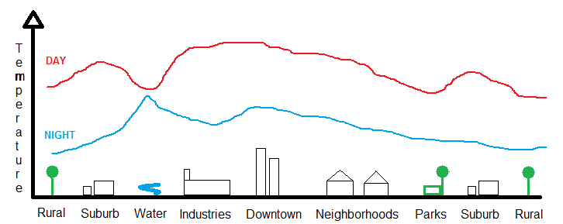
Figure 1 – Temperature diagram in cities

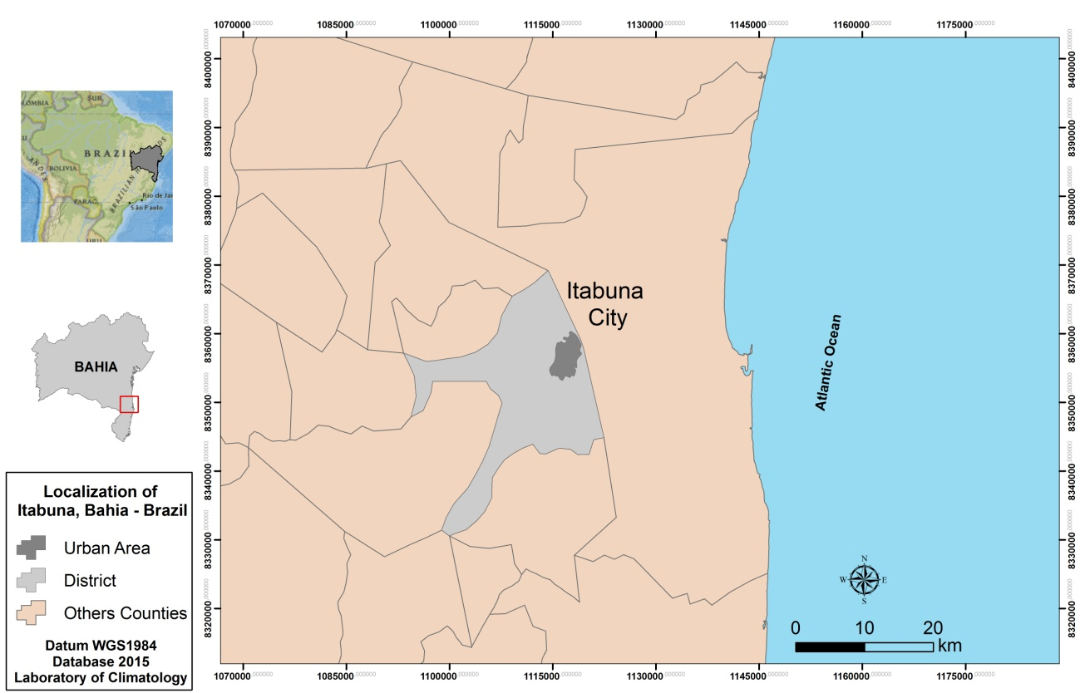
Figure 2 – Location of the municipality of Itabuna and its urban area.
Source: Cartographic Base of Climatology Laboratory of UESC.

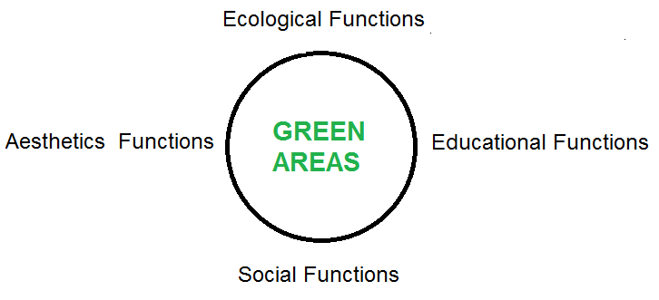
Figure 3 -Ideal scope of a green area.

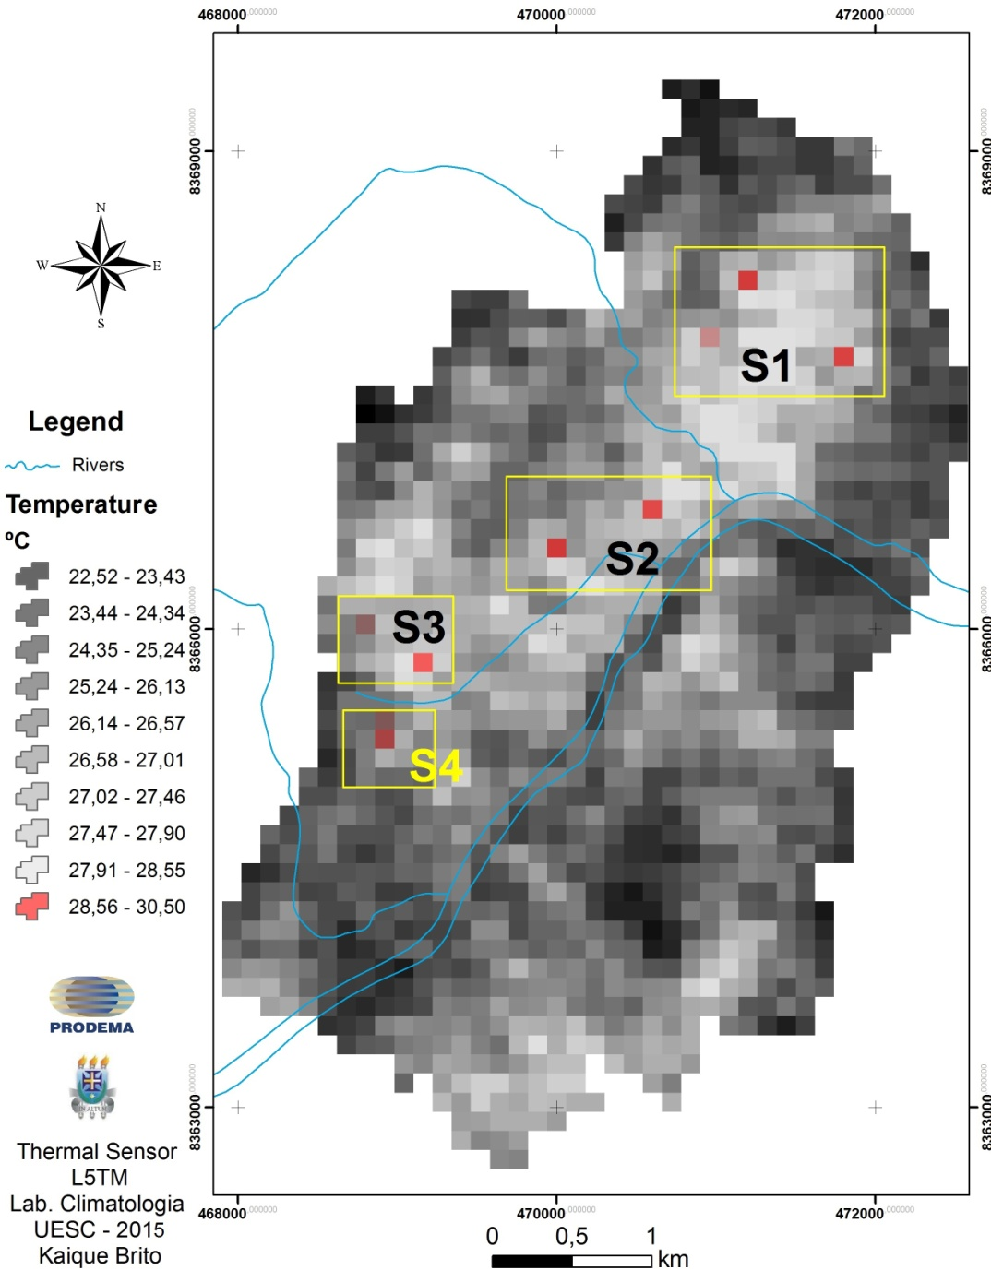
Figura 4 – Heat islands in the Itabuna city
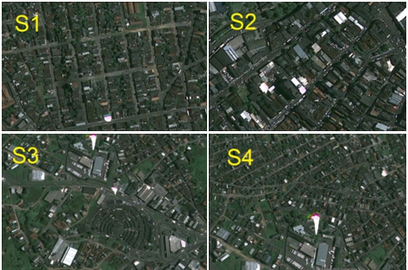
Figure 5 – View of the identified groups
Source: Esri Imagery, 2015

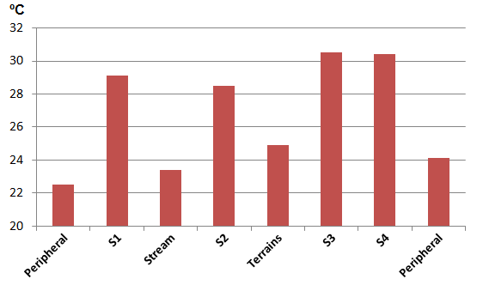

Figure 6 – Longitudinal temperature profile drawn between sectors 1 and 4.

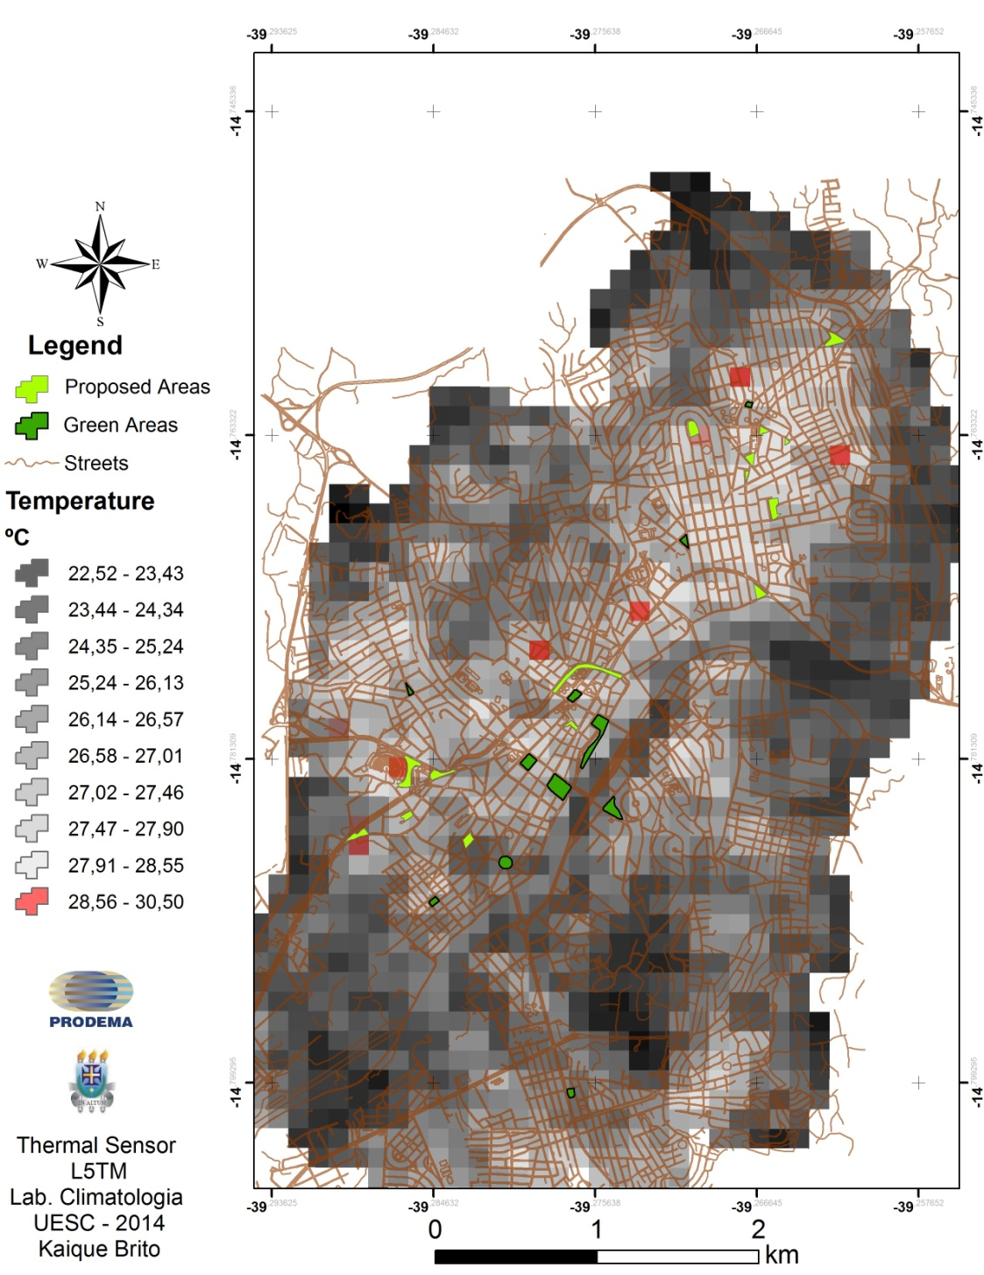
Figure 7 – Proposed and existing green areas

