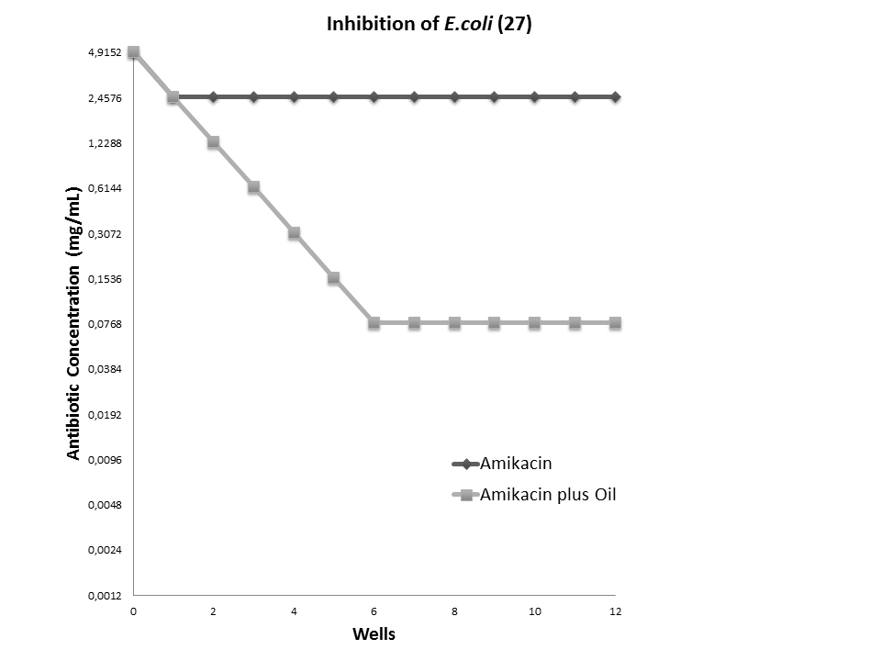

Figura 1. Determination of minimum inhibitory concentration of amikacin against E. coli 27 and its modulation by B. virgilioides oil at 64 µg/mL.

