- (b)
Fig. 1 Sea breeze satellite image visualization the white line corresponds to the coast line whereas the red line corresponds to the sea breeze front. (a) Brazilian coast, (b) England coast (Corpetti et al 2010).

Fig. 2 Computing domain satellite image
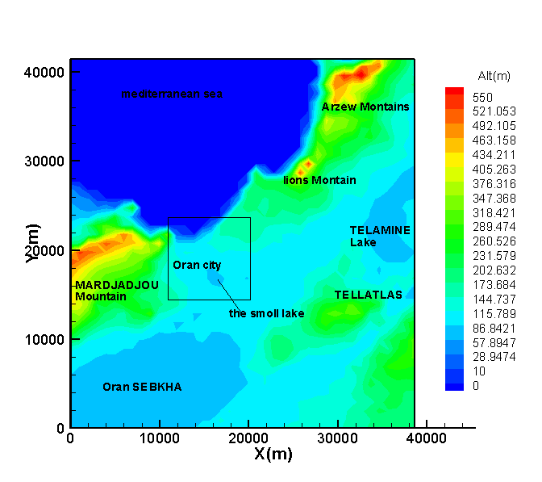

Fig.3 Oran agglomeration topographic field

Fig.4 three domension view of Oran agglomeration topography
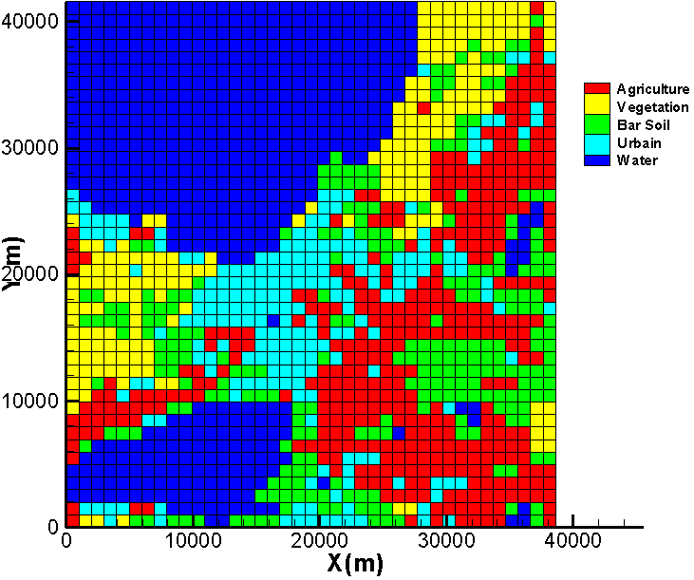
Fig. 5 Simulation domain soil types

Fig. 6 The 3D grid simulation with the zoo of the first levels
(a)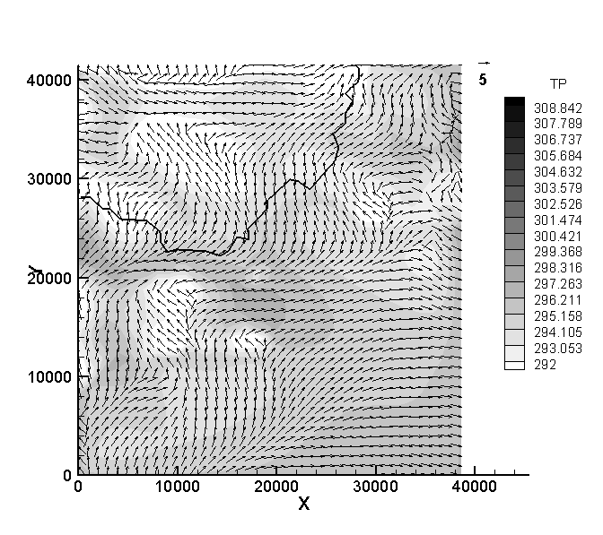 (b)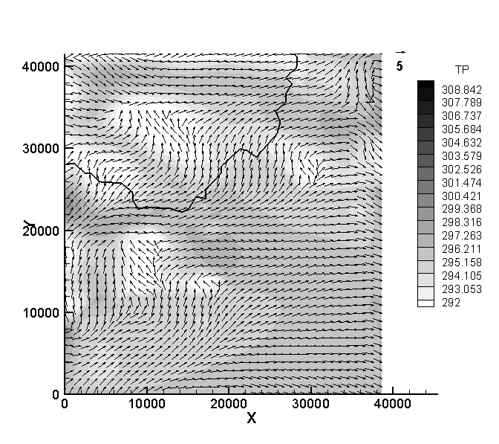
(c)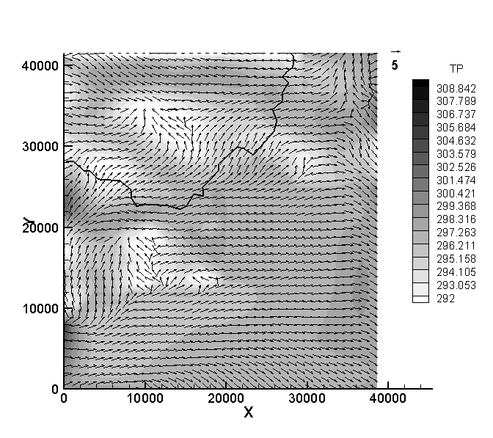 (d) 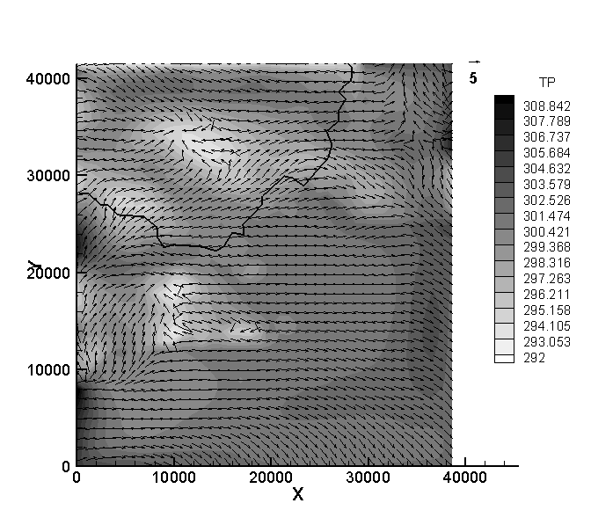

Fig. 7 Potential temperature field (in Kelvin) and horizontal section at the first SUBMESO model level (z = 7.5m), with the horizontal wind velocity (m/s) vector and the cost line, with black line corresponds to coast line, (a) at 1 UTC, (b) at 2 UTC, (c) at 3 UTC, (b) at 4 UTC.
- 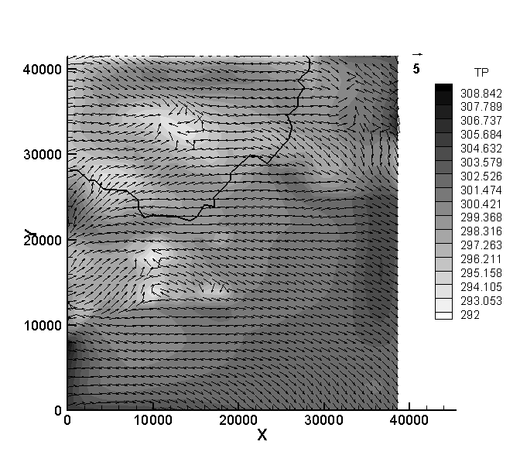 (b) 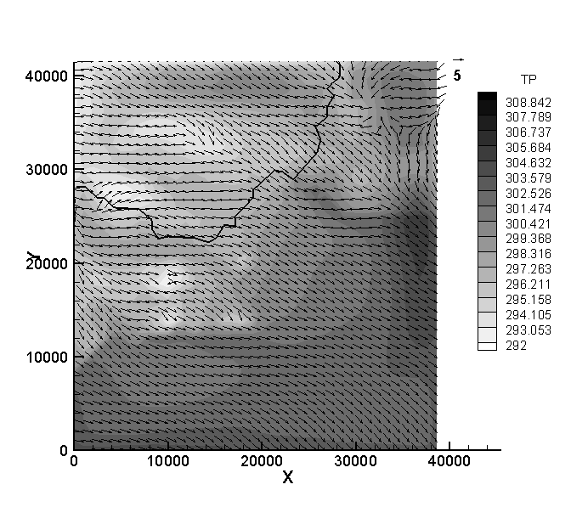
(c)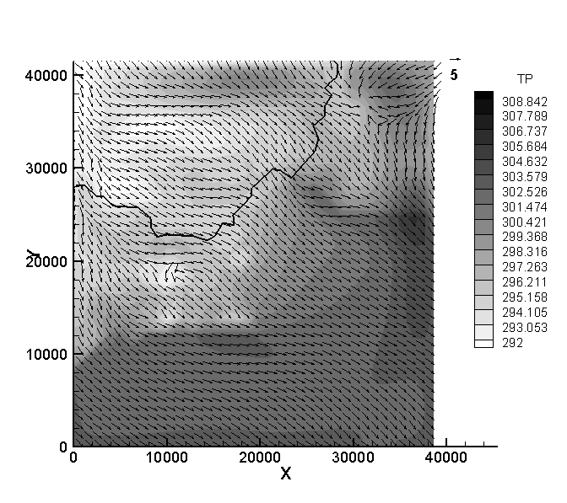 (d) 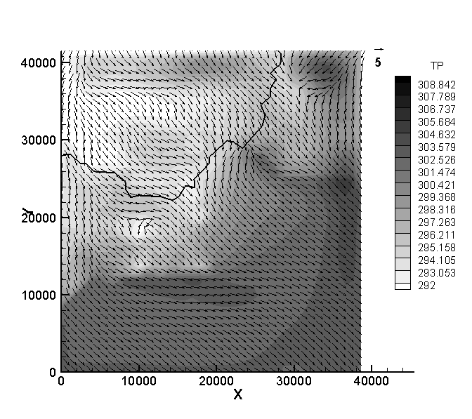
Fig. 8 Potential temperature field (in Kelvin) and horizontal section at the first SUBMESO model level (z = 7.5m), with the horizontal wind velocity (m/s) vector and the cost line, with black line corresponds to coast line, (a) at 6 UTC, (b) at 7 UTC, (c) at 8 UTC, (b) at 9 UTC.
- 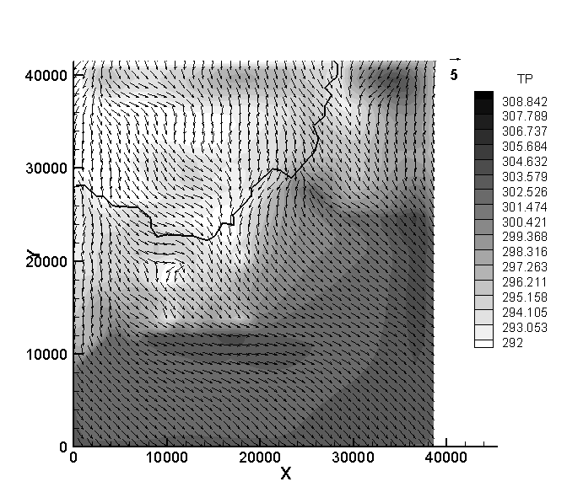(b)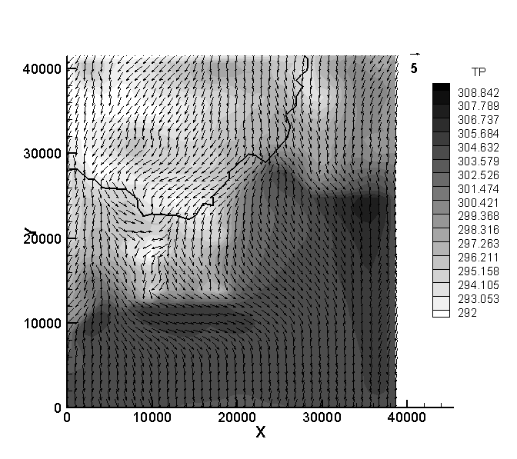
Fig. 9 Potential temperature field (in Kelvin) and horizontal section at the first SUBMESO model level (z = 7.5m), with the horizontal wind velocity (m/s) vector and the cost line, with black line corresponds to coast line, (a) at 13 UTC, (b) at 14 UTC.
(a)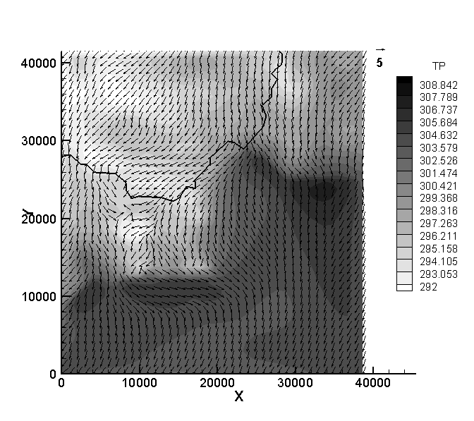(b)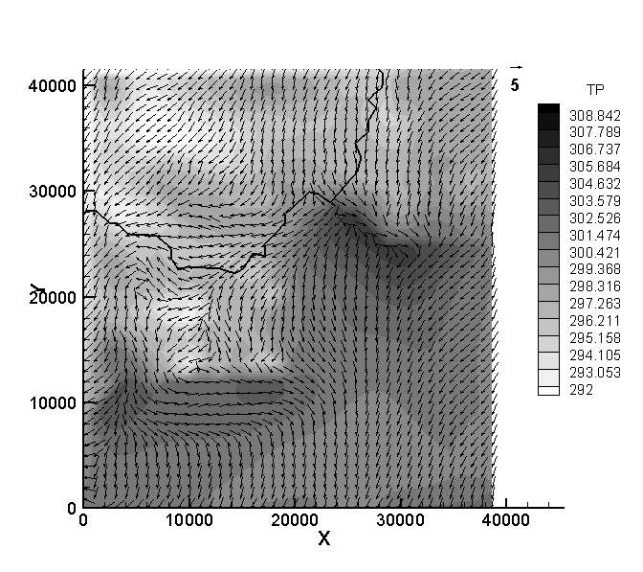
(c)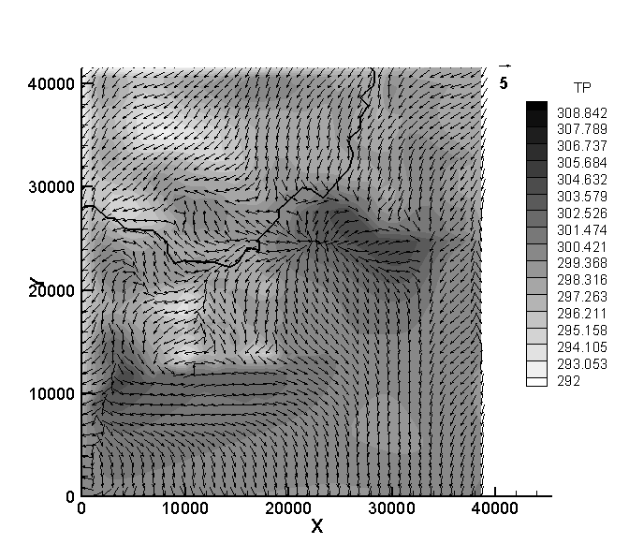(d)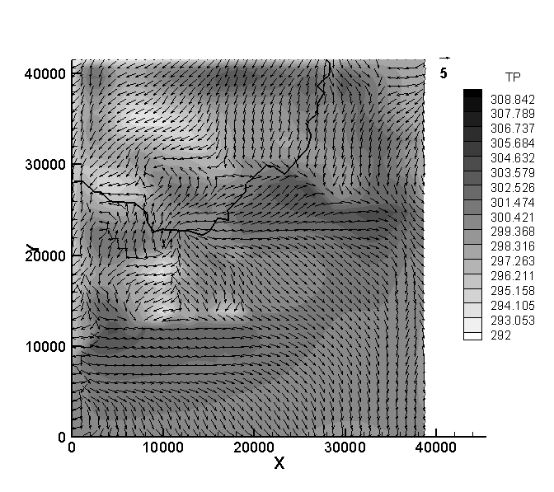
Fig. 10 Potential temperature field (in Kelvin) and horizontal section at the first SUBMESO model level (z = 7.5m), with the horizontal wind velocity (m/s) vector and the cost line, with black line corresponds to coast line, (a) at 15 UTC, (b) at 16 UTC, (c) at 18 UTC, (d) at 20 UTC.
(a)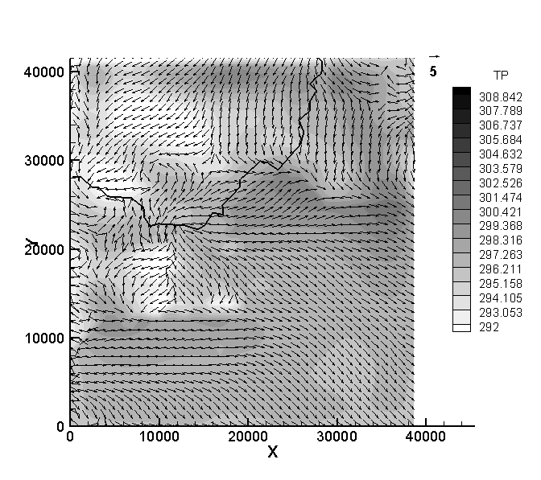(b)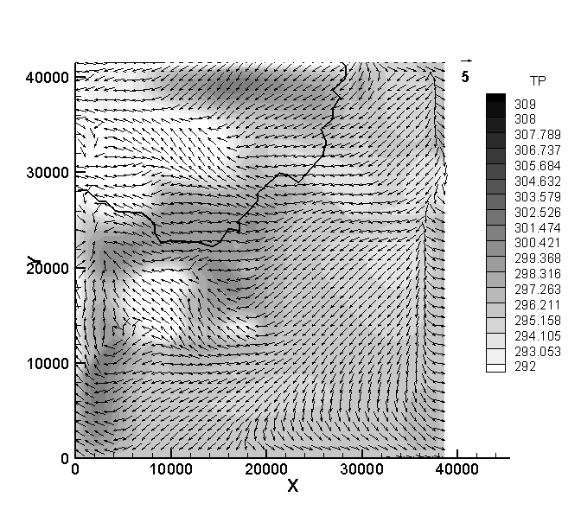
Fig. 11 Potential temperature field (in Kelvin) and horizontal section at the first SUBMESO model level (z = 7.5m), with the horizontal wind velocity (m/s) vector and the cost line, with black line corresponds to coast line, (a) at 22 UTC, (b) at 24 UTC.
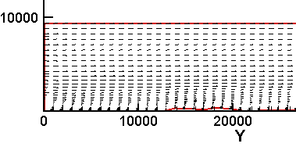
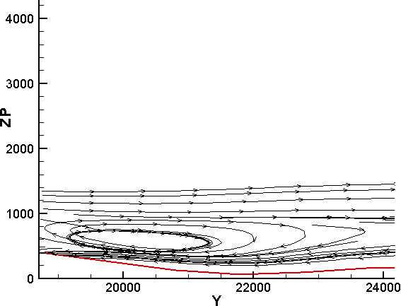

Fig. 12 The topography line with the velocity stream lines on the vertical plane (Y, Z)

