 | Journal of Urban and Environmental Engineering, v.3, n.2 (2009), p. 43–51 | Journal of Urban and Environmental Engineering
 | ISSN 1982-3932  doi: 10.4090/juee.2009.v3n1.043051 | www.journal-uee.org

PREDICTION OF POWER GENERATION OF SMALL SCALE VERTICAL AXIS WIND TURBINE USING FUZZY LOGIC

Altab Hossain¹∗, Ataur Rahman², Mozasser Rahman², SK. Hasan², and Jakir Hossen³
¹Department of Mechanical Engineering, Faculty of Engineering, Universiti Industri Selangor,
45600, Kuala Selangor, Malaysia
²Faculty of Engineering, International Islamic University Malaysia, Malaysia
³Department of Electrical Engineering, Faculty of Engineering, Multimedia University, Malaysia

Received 10 August 2009; received in revised form 06 November 2009; accepted 12 November 2009

Abstract: | Renewable energy from the wind turbine has been focused for the alternative source of power generation due to the following advances of the of the wind turbine. Firstly, the wind turbine is highly efficient and eco-friendly. Secondly, the turbine has the ability to response for the changeable power generation based on the wind velocity and structural framework. However, the competitive efficiency of the wind turbine is necessary to successfully alternate the conventional power sources. The most relevant factor which affects the overall efficiency of the wind turbine is the wind velocity and the relative turbine dimensions. Artificial intelligence systems are widely used technology that can learn from examples and are able to deal with non-linear problems. Compared with traditional approach, fuzzy logic approach is more efficient for the representation, manipulation and utilization. Therefore, the primary purpose of this work was to investigate the relationship between wind turbine power generation and wind velocity, and to illustrate how fuzzy expert system might play an important role in prediction of wind turbine power generation. The main purpose of the measurement over the small scaled prototype vertical axis wind turbine for the wind velocity is to predict the performance of full scaled H-type vertical axis wind turbine. Prediction of power generation at the different wind velocities has been tested at the Thermal Laboratory of Faculty of Engineering, Universiti Industri Selangor (UNISEL) and results concerning the daily prediction have been obtained.
Keywords: | Wind Turbine; Power Generation; Wind Velocity; Fuzzy Logic
© 2009 Journal of Urban and Environmental Engineering (JUEE). All rights reserved.

INTRODUCTION
Energy is the essential input for the national development in the form of mechanical power or any other. It has major contribution for improving the quality of life and enhancing economic growth. In addition to conventional energy resources, renewable energy can also play a vital role for energy demand, of which wind energy is one. Wind energy is the kinetic energy associated with the movement of atmospheric air. It has been used for hundreds of years for sailing, grinding grain, and for irrigation. Wind energy systems for irrigation and milling have been in use since ancient times and since the beginning of the 20th century it is being used to generate electric power. Windmills for water pumping have been installed in many countries particularly in the rural areas. Electrical power generation is a fast-growing source of clean power production from wind in large, relatively remote wind-farms which is then transferred to residential and commercial places. The total amount of electricity that could potentially be generated from wind in the United States has been estimated at 10,777 billion kWh annually (Keith, 2005). The United States Department of Energy has recently set up a schedule to implement the latest research in order to build wind turbines with a higher efficiency rating than is now possible-(the efficiency of an ideal wind turbine is 59.3 percent (Milligan & Artig, 1999). Wind turbine is a machine that converts the wind's kinetic energy into rotary mechanical energy, which is then used to do work. In more advanced models, the rotational energy is converted into electricity, the most versatile form of energy, by using a generator (Fitzwater et.al, 1996).

Many research works have been carried out by Walters et al. (1979), Musgrove (1987), Eriksson & Bernhoff, 2005), and Greg et al. (2009) due to the demand for supply of electricity from wind turbines and different types of wind turbines have been developed and are available in the market for solving the wind power problems. Based on previous researches on wind turbine, a new design concept of “1/3 scale H-type, vertical axis wind turbine” was proposed and a prototype has been developed (Hossain et al., 2007). It has the capability to self-start due to the wind flow and efficient performance of the VAWT that could lead to a change in the standard thinking of how wind energy is harnessed, and may spur future VAWT design and research. The study on the enhanced performance of the wind turbine was also given by incorporating drag devices.
Power generation by wind velocity is a complex process with many interacting factors. For this reason, mathematical models have been developed to help to understand this phenomenon (Hossain et al., 2007). Much scientific knowledge has been accumulated on this subject, but not in a useful way for farm transportation decisions.
Soft computing technology is an interdisciplinary research field in computational science. At present, various techniques in soft computing such as statistics, machine learning, neural network and fuzzy data analysis are being used for exploratory data analysis. In recent years, the methods of Artificial intelligence have largely been used in the different areas including the transportation, agricultural, and industrial applications. In the power generation area, many expert systems were designed. Based on the studies on vertical and horizontal axis wind turbine (Hossain, 2001), an intelligent system using Fuzzy Logic was proposed to predict the power generation. Fuzzy Logic has been applied successfully to a large number of expert applications. Fuzzy expert system, a relatively new, intelligent, knowledge based technique performs exceptionally well in non linear, complex systems.
Fuzzy set theory is an artificial intelligence technique that makes use of fuzzy sets and fuzzy ‘linguistic’ rules to incorporate this uncertainty into the model. Classical set theory can be extended to handle partial memberships, enabling to express vague human concepts using fuzzy sets and also describe the corresponding inference systems based on fuzzy rules (Kalogirou, 2003). ‘Fuzzy set theory’ is often replaced by the term ‘fuzzy logic’. The central concept of fuzzy set theory is a membership function, which represents numerically to what degree an element belongs to a set. In fuzzy set theory, an element can be a member of a particular set to a certain degree and at the same time be a member of a different set to a certain degree. To what degree an element belongs to a certain set is called the membership degree. In fuzzy rule-based systems, knowledge is represented by if–then rules. Fuzzy rules consist of two parts: an antecedent part stating conditions on the input variable(s) and a consequent part describing the corresponding values of the output variable(s) (Ross, 1995). The aim of this study was the construction of fuzzy knowledge-based models for the prediction of the power generation by controlling wind velocity of wind turbine based on the Mamdani approach. Sampling data collected from the operation were used to validate the fuzzy models.

MATERIALS AND METHODS
Structure design of wind turbine
The top and bottom of each blade is a 1066.8 mm x 139.7 mm x 50.8 mm deep rectangular section to allow for easier connections to the radial arms and passive pitching system. In this study the corner sharp has been selected as the shape of the blade for its very high capability to face the resistance of wind flow and faster rotation during the wind flow. The final assembly of the wind turbine has been set at Thermal Laboratory in Universiti Industri Selangor and is shown in Fig. 1. There are 18 parts and 15 screws combined together in the assembly process. The shaft is connected to the main parts and to the alternator during the full assembly of this vertical axis wind turbine. The belt drive system consists of several parts of the belt drive calculation and the V–Type belt is considered in this study.

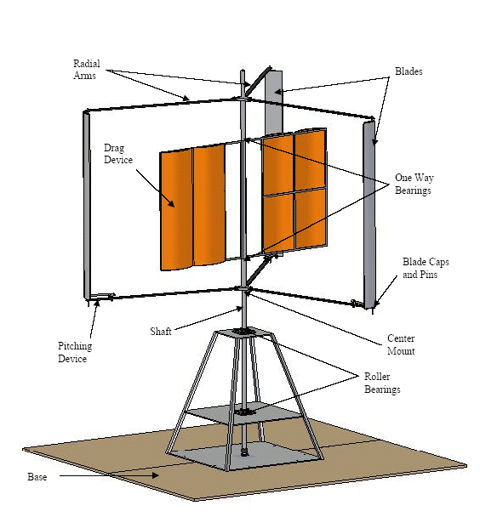
Fig. 1 Final assembly of the prototype wind turbine.

The components of the small scaled vertical axis wind turbine are designed by using the CATIA software in the Structural Laboratory in Unisel and assembled together to predict the full scale. The wind turbine is a three bladed with tapered wing sections connected to the rotor of the generator and has been tested at an open hall. The corner sharp has been used as aerofoil for the wind turbine blade by producing a controllable aerodynamic force with its motion through the wind flow.

Theoretical model and analyses
Wind power of the turbine is defined as (Bench & Cloud, 2004),
$P_{\text{wind}}=\frac{1}{2}ρ_{∞}S_{T}v_{∞^{3}}$ (1)
Where, $ρ_{∞}$ is the density of air in kg/m³, $S_{T}$ is the total frontal area in m², and $v_{∞}$ is the wind velocity in m/s.

Using equations of state for perfect gas the air density, $ρ_{∞}$ is defined as (Bertin, 2002),
$ρ_{∞}=\frac{p}{\text{RT}}$ (2)
Where, p is the absolute pressure in N/m², T is the temperature in K, and R is the gas constant of air in Nm/(kg) (K).
Reynolds number based on the chord length is defined as (Anderson, 1999):

$\text{Re}=\frac{ρ_{∞}v_{∞}c}{μ_{∞}}$ (3)

Where, $v_{∞}$is the free stream velocity in m/s; $μ_{∞}$ is the dynamic viscosity in kg/(m)(s) and $c$is the chord length in m.

The air viscosity, $μ_{∞}$ is determined using the Sutherland’s equation (Bertin, 2002) described below:

$μ_{∞}=1\text{.}\text{458}×{\text{10}}^{−6}\frac{T^{1⋅5}}{T+\text{110}\text{.}4}$ (4)

where, T is the temperature in K.
The prototype of the Unisel wind turbine is installed at the Thermal Laboratory in Universiti Industri Selangor and a number of preliminary tests have been carried out on the device, which has operated successfully. Before starting the operation, the battery terminal and alternator terminal are checked properly and it is connected with the lamp and switch. Then the wind turbine is allowed to rotate. Due to the rotation of the wind turbine blade voltage is produced and the connected lamps are turned on (Fig. 2).

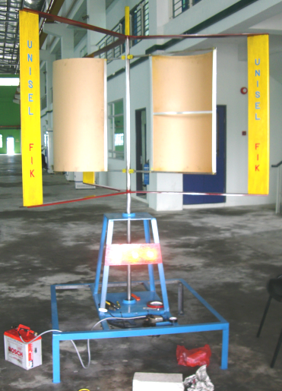

Fig. 2 Experiment of power generation with wind turbine.
The produced voltage readings and the respective turbine rotations are recorded. The ambient pressure and temperature are recorded using the manometer and thermometer for the evaluation of air density in the Laboratory environment of Universiti Industri Selangor. The power produced by the wind speed is also calculated which is shown in the specimen calculation section. The main test is performed at open hall in the Thermal Laboratory of Faculty of Engineering, UNISEL, where wind speeds are measured between 4 and 6 m/s, with gusts up to 7 m/s. During the test, the turbine has been run based on the design, then the blades are opened and the wind has been propelled, and finally it has been checked about sufficient production of lift when the blades are closed. It has been seemed as though the turbine would slow down too much in the regions where lift is not produced thus the blades are kept opening up just to allow rotation. Next the blades have been opened to check the maximum attainable rotational speed in the drag position. In this position it is observed that there is plenty of windswept area to rotate the turbine.
For the different measured velocities, corresponding Reynolds numbers and wind power calculated as shown in Table 1 (Hossain et al., 2007). The simulation on the wind turbine design parameters and power generation are conducted by using the MATLAB.

FUZZY EXPERT SYSTEM
There are a number of different techniques that would work here and therefore a design choice must be made. Some of the techniques require a relatively accurate model of the system in order to develop a satisfactory system. Fuzzy Logic system, on the other hand, does not require a model of the system. Instead, they rely on the knowledge of an expert for the particular system. Therefore, with all of this in mind, a Fuzzy Logic expert system is introduced for the prediction of wind power generation from the wind turbine. The main advantage of Fuzzy Logic is that it can be tuned and adapted if necessary, thus enhancing the degree of freedom of the system (Rajagopalan et al., 2003).

Table 1. Free stream velocity, Reynolds number and corresponding wind power generation.
Serial No | Free stream velocity (m/s) | Reynolds number | Wind power  (W)
1 | 5.89 | 4.89E+04 | 132.19
2 | 5.95 | 4.94E+04 | 136.27
3 | 6.08 | 5.05E+04 | 145.40
4 | 6.38 | 5.30E+04 | 168.00
5 | 6.58 | 5.47E+04 | 184.30
6 | 6.87 | 5.71E+04 | 209.76
7 | 7.02 | 5.83E+04 | 223.80
Fuzzy Rule Base
Defuzzification
Fuzzy Inference Engine
Fuzzification
Crisp
data
Crisp
data

Fig. 3 The basic structure of the fuzzy system.

The general configuration of the fuzzy expert system, which is divided into four main parts, is shown in Fig. 3. The first part is the fuzzification, in this part crisp inputs are transformed to fuzzy values. Fuzzy sets enter the inference engine which maps the input values using normalized membership functions. The fuzzy-logic inference engine deduces the proper control action based on the available rule base. The fuzzy control action is translated to the proper crisp value through the defuzzifier using normalized membership functions.
For implementation of fuzzy values into the models, the fuzzy logic toolbox from MATLAB was used. For prediction of power generation from the wind turbine by using Fuzzy expert system (FES), wind velocity (WV) and chord length of the blade (BC) were used as input parameters and wind power generation (WP) was used as output. For fuzzification of these factors the linguistic variables very low (VL), low (L), medium (M), high (H), and very high (VH) were used for the inputs and output. In this study, the center of gravity (Centroid) method for defuzzification was used because these operators assure a linear interpolation of the output between the rules. The units of the used factors were: WV (m/s), BC (m), and WP (W).
With the fuzzy sets defined, it is possible to associate the fuzzy sets in the form of fuzzy rules. For the two inputs and one output, a fuzzy associated memory or decision (also called rule) table is developed as shown in Table 2. Total of 25 rules were formed. For example, Rule 1 can be interpreted as follows.
Rule 1: If wind velocity (WV) is VL and chord length of the blade (BC) is VL, then wind power generation (WP) is VL.

Fuzzification
The first block inside the fuzzy expert system (FES) is fuzzification, which converts each piece of input data to degrees of membership by a lookup in one or several membership functions. The fuzzification block thus matches the input data with the conditions of the rules to determine how well the condition of each rule matches that particular input instance. There is a degree of membership for each linguistic term that applies to that input variable.

Table 2. Rule base of fuzzy expert system.
Rules | Input variables |  | Output variable
Rules | WV | BC | WP
Rule 1 | VL | VL | VL
Rule 2 | VL | L | VL
Rule 3 | VL | M | VL
Rule 4 | VL | H | VL
Rule 5 | VL | VH | L
Rule 6 | L | VL | VL
Rule 7 | L | L | L
Rule 8 | L | M | M
Rule 9 | L | H | M
Rule 10 | L | VH | H
Rule 11 | M | VL | M
Rule 12 | M | L | M
Rule 13 | M | M | M
Rule 14 | M | H | M
Rule 15 | M | VH | H
Rule 16 | H | VL | M
Rule 17 | H | L | M
Rule 18 | H | M | H
Rule 19 | H | H | H
Rule 20 | H | VH | H
Rule 21 | VH | VL | M
Rule 22 | VH | L | H
Rule 23 | VH | M | H
Rule 24 | VH | H | VH
Rule 25 | VH | VH | VH

Fuzzifications of the used factors are made by aid follows functions. These formulas were determined by using measurement values.

$\text{WV}\left(i_{1}\right)=\left\{\begin{matrix}i_{1};4≤i_{1}≤8 \\ 0;\text{otherwise}\end{matrix}\right\}$ (5)

$\text{BC}\left(i_{2}\right)=\left\{\begin{matrix}i_{2};0\text{.}\text{005}≤i_{2}≤0\text{.}\text{16} \\ 0;\text{otherwise}\end{matrix}\right\}$ (6)

$\text{WP}\left(o_{1}\right)=\left\{\begin{matrix}o_{1};\text{120}≤o_{1}≤\text{240} \\ 0;\text{otherwise}\end{matrix}\right\}$ (7)

Membership Functions
Using MATLAB FUZZY Toolbox, prototype triangular fuzzy sets for the fuzzy variables, namely, wind velocity
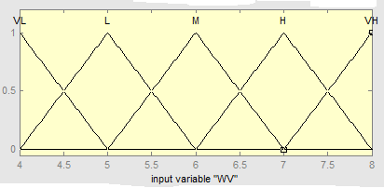
Fig. 4a Prototype membership functions for wind velocity.

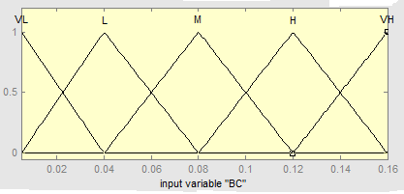
Fig. 4b Prototype membership functions for chord length of blade.

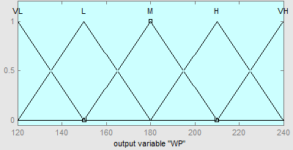
Fig. 4c Prototype membership functions for wind power generation.

(WV), chord length of the blade (BC) and wind power generation (WP) are set up. The membership values used for the FES were obtained from above the formulas and are shown in the Figs. 4a−4c. These membership functions helped in converting numeric variables into linguistic terms. For example, the linguistic expressions and membership functions for wind velocity (WV) obtained from the developed rules and above the formula are given as following.

$μ_{\text{VL}}\left(i_{1}\right)=\begin{aligned} \\ \end{aligned}$ (8)

$μ_{\text{VL}}\left(i_{1}\right)=\left\{14+0\text{.}\text{75}4\text{.}\text{25}+0\text{.}54\text{.}5+0\text{.}\text{25}4\text{.}\text{75}+05\right\}$ (9)

$μ_{L}\left(i_{1}\right)=\begin{aligned}\left\{\frac{i_{1}−4}{1};4≤i_{1}≤5 | \right\}\left\{\frac{6−i_{1}}{1};5≤i_{1}≤6 | \right\}\end{aligned}\left\{\right\}$ (10)

$μ_{L}\left(i_{1}\right)=\left\{04+0\text{.}54\text{.}5+15+0\text{.}55\text{.}5+06\right\}$ (11)

$μ_{M}\left(i_{1}\right)=\begin{aligned}\left\{\frac{i_{1}−5}{1};5≤i_{1}≤6 | \right\}\left\{\frac{6−i_{1}}{1};6≤i_{1}≤7 | \right\}\end{aligned}\left\{\right\}$ (12)

$μ_{M}\left(i_{1}\right)=\left\{05+0\text{.}55\text{.}5+16+0\text{.}56\text{.}5+07\right\}$ (13)

$μ_{H}\left(i_{1}\right)=\begin{aligned}\left\{\frac{i_{1}−6}{1};6≤i_{1}≤7 | \right\}\left\{\frac{8−i_{1}}{1};7≤i_{1}≤8 | \right\}\end{aligned}\left\{\right\}$ (14)

$μ_{H}\left(i_{1}\right)=\left\{06+0\text{.}56\text{.}5+17+0\text{.}57\text{.}5+08\right\}$ (15)

$μ_{\text{VH}}\left(i_{1}\right)=\begin{aligned}\left\{0;i_{1}≤7 | \right\}\left\{\frac{7−i_{1}}{1};7≤i_{1}≤8 | \right\}\end{aligned}\left\{\right\}$ (16)

$μ_{\text{VH}}\left(i_{1}\right)=\left\{07+0\text{.}57\text{.}5+18\right\}$ (17)

Inference step: Determining Conclusions
The determination of conclusion is taken when the rules that are applied to deciding what the wind power generation to the plant (wind turbine) should be. To do this, the recommendations of each rule are considered independently. Then later all the recommendations from all the rules are combined to determine the wind power generation input to the wind turbine.
In defuzzification stage, truth degrees (μ) of the rules were determined for the each rule by aid of the min and then by taking max between working rules. For example, for WV = 6 m/s and BC = 0.14 m, the rules 14 and 15 will be fired. Notice that $μ_{M}\left(\text{WV}\right)=1$ but that the other membership functions for the WV inputs are all “off” (i.e., their values are zero). For the BC input it is seen that $μ_{H}\left(\text{BC}\right)=0\text{.}5$ and $μ_{\text{VH}}\left(\text{BC}\right)=0\text{.}5$ and that the other membership functions are off.

Recommendation from Rule 14
Using the minimum to represent the premise (M), we have $μ_{M_{\left(\text{14}\right)}}=$ min {$μ_{M}\left(\text{WV}\right)$, $μ_{H}\left(\text{BC}\right)$} = min {1, 0.5} = 0.5, that is, using the minimum of the two membership values. The notation $μ_{\text{14}}$ represents for rule (14) so that we are 0.5 certain that this rule applies to the current situation. This rule indicates that if its premise is true then the action indicated by its consequent should be taken. For rule (14) the consequent is “wind power is medium”. The membership function for the conclusion reached by rule (14), which is denoted as$μ_{\text{14}}$, is given by $μ_{\text{14}}\left(\text{WP}\right)=$ min {0.5, $μ_{M}\left(\text{WP}\right)$}. This membership function defines the implied fuzzy set for rule (14).

Recommendation from Rule 15
Using the minimum to represent the premise (H), we have min {, } = min {1, 0.5} = 0.5, that is, using the minimum of the two membership values. So that we are 0.5 certain that this rule applies to the current situation. This rule indicates that if its premise is true then the action indicated by its consequent should be taken. For rule (15) the consequent is “wind power is high”. The membership function for the conclusion reached by rule (15), which is denoted as$μ_{\text{14}}$, is given by $μ_{\text{15}}\left(\text{WP}\right)=$ min {0.5, $μ_{H}\left(\text{WP}\right)$}.
This membership function defines the implied fuzzy set for rule (15). It is noticed that we are certain that both rule (14) and (15) apply to the current situation. From Mamdani max–min inference, the membership function of system will be found as max (μ₁₄, μ₁₅) = 0.5.

Converting Decisions into Actions: Defuzzification Module
In this stage defuzzification operation is considered that is the final component of the fuzzy controller. Defuzzification operates on the implied fuzzy sets produced by the inference mechanism and combines their effects to provide the “most certain” controller output (plant input). Then the one output denoted by “WP ^{crisp}” can be calculated that best represents the conclusions of the fuzzy controller that are represented with the implied fuzzy sets. Due to its popularity, the “center of gravity” (COG) defuzzification method is used for combing the recommendations represented by the implied fuzzy sets from all the rules (Passino & Yurkovich, 1998).

Center of gravity (GOG) defuzzification method
Let b_{i} denotes the center of the membership function (i.e., where it reaches its peak) of the consequent rule i and let $\int{μ_{{}_{\left(i\right)}}}$denote the area under the membership function μ_{(i)}. The COG method computes WP ^{crisp} to be:

${\text{WP}}^{\text{crisp}}=\frac{\sum{b_{i}\int{μ_{{}_{\left(i\right)}}}}}{\sum{\int{μ_{{}_{\left(i\right)}}}}}$ (18)

where the crisp output value WP is the abscissa under the centre of gravity of the fuzzy set. The expression can be interpreted as the weighted average of the elements in the support set. It is a much used method although its computational complexity is relatively high. This method is also called centroid of area.

Center of gravity method for singletons (GOGS) defuzzification method
The output membership values are multiplied by their corresponding singleton values and then are divided by the sum of membership values.

${\text{WP}}^{\text{crisp}}=\frac{\sum{b_{i}μ_{{}_{\left(i\right)}}}}{\sum{μ_{{}_{\left(i\right)}}}}$ (19)

where b_{i} is the position of the singleton in i the universe, and μ_{(i)} is equal to the firing strength of truth values of rule i. This method has a relatively good computational complexity, and t is differentiable with respect to the singletons b_{i}, which is useful in neurofuzzy systems.
For the rule 14 and 15, from Fig. 4c, we have $b_{\text{14}}=\text{180}$and $b_{\text{15}}=\text{210}\text{.}$ Using Eq. (18) with Fig. 4c we have: ${\text{WP}}^{\text{crisp}}=\frac{\left(\text{180}\right)\left(\text{22}\text{.}5\right)+\left(\text{210}\right)\left(\text{22}\text{.}5\right)}{\text{22}\text{.}5+\text{22}\text{.}5}=\text{195}$. i.e., wind power generation should be 195 W.
The implied fuzzy set from rule (14) is given by the
membership function $μ_{\text{14}}\left(\text{WP}\right)=0\text{.}5μ_{M}\left(\text{WP}\right)$ and the implied fuzzy set from rule (15) is given by the membership function$μ_{\text{15}}\left(\text{WP}\right)=0\text{.}5μ_{M}\left(\text{WP}\right)$.
Using equation (19) we have, ${\text{WP}}^{\text{crisp}}=\frac{\left(\text{180}\right)\left(0\text{.}5\right)+\left(\text{210}\right)\left(0\text{.}5\right)}{0\text{.}5+0\text{.}5}=\text{195}$.
This just happens to be the same value as above.

3.5 Control Surface
With two inputs and one output the input-output mapping is a surface. Using MATLAB the fuzzy control surface is developed as shown in Fig. 5 and it is a mesh plot of an example relationship between wind velocity WV and chord length of blade BC on the input side, and controller output wind power WP on the output side. This control surface is the output plotted against the two inputs, and displays the range of possible defuzzified values for all possible inputs.
The plot results from the interpolation of rule base with twenty five rules. The plot is used to check the rules and the membership functions and to see if they are appropriate and whether modifications are necessary to improve the output. If necessary, the rule base for the fuzzy sets is modified until the output curves are desired. When a satisfactory system is achieved, the fuzzy program is converted to machine language and downloaded into a microprocessor controller. Although the process seems to be long, it actually is relatively easy to do, and it adds intelligence to a machine.

RESULTS AND DISCUSSIONS
Based on the measurement of velocity the wind power for this prototype is calculated and presented in the Fig. 6. It is observed that the wind power generation increased linearly with greater wind velocity. The wind power generation for all tests was in the range 132.19-223.80 W. According to the test results, the greater the wind velocity and chord length of the blade showed higher values of wind power generation.

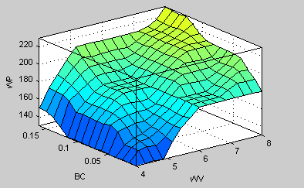
Fig. 5 Control surface of the fuzzy inferring system.

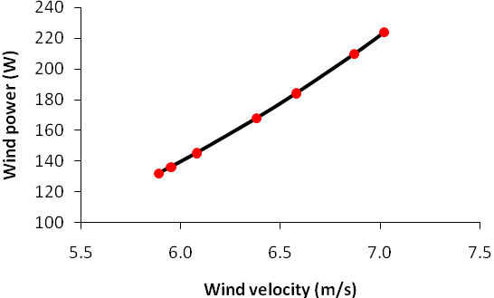
Fig. 6 Wind power generation versus wind velocity.
The results of the developed fuzzy expert system (FES) were compared with the experimental results. For wind power generation, the mean of measured and predicted values were 171.39 and 198.57 W respectively. The coreelation between measured and predicted values (from FES model) of wind power generation in differen wind velocities was given in Fig. 7. The relationship was significant for all parameters. The correlation coefficient of reltionship was found as 0.88. the mean relative error of measured and predicted valus (from FES model) was found as 6.17% for the maximum wind velocity and wind power generation which was found to be less than the acceptable limits (10%) (Taner, 2007). The goodness of fit of prediction (from FES model) value was found as 0.89 which was found to be close to 1.0.

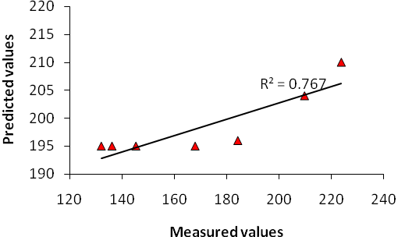
Fig. 7 Correlation between measured and predicted values of wind power generation.

CONCLUSION
This paper presents an adaptive approach based on the use of fuzzy logic for the prediction of wind power generation which is necessary for the current renewable energy utilization in many countries particularly in the rural areas. In comparison to other predictive modeling techniques, fuzzy models have the advantage of being simple (rule base and membership functions) and robust. In this study, according to evaluation criteria of predicted performances of developed fuzzy knowledge-based model was found to be valid. However, the conclusions drawn from this investigation are as follows:
- The developed model can be used as a reference for further renewable energy studies.
- This system can be developed further by increasing the knowledge rules and by addition of Genetic-Fuzzy and Neuro-Fuzzy to the system.

Acknowledgment The authors are grateful for the support provided by financial assistance from the Universiti Industri Selangor, and Faculty of Engineering for the overall facilities.

Nomenclature
Symbol | Meaning | Unit
$$p$$ | Absolute pressure | (N/m²)
$$T$$ | Temperature | (K)
$$R$$ | Gas constant | (Nm/kg.K)
$$ρ_{∞}$$ | Air density | (kg/m³)
$$μ_{∞}$$ | Air viscosity | (kg/m.s)
$$v_{∞}$$ | Free stream velocity | (m/s)
$$c$$ | Blade chord length | (m)
$$\text{Re}$$ | Reynolds number | (Dimensionless)
$$S_{T}$$ | Total frontal area | (m²)
$$P_{\text{wind}}$$ | Wind power | (W)

REFERENCES
Anderson Jr., J.D. (1999) Aircraft Performance and Design, McGraw Hill Companies Inc., U.S.A.
Bench, S.E. & Cloud, P.K. (2004) The Measure, Predict and Calculate the Power response of an Operating Wind Turbine. 1st Ed., London, Jepson Pub, pp. 366.
Bertin, J.J. (2002) Aerodynamics for the Engineer, New Jersey, Prentice Hall, Inc., U.S.A.
Eriksson, S. & Bernhoff, H. (2005) Generator-damped Torsional Vibrations of a Vertical Axis Wind Turbine. Wind Engineering, 29(5), 449-462.
Fitzwater, L.M., Cornell, C.A. & Veers, P.S. (1996) Using Environmental Contours to Predict Extreme Events on Wind Turbines. Wind Energy Symposium, AIAA/ASME, n. 9, 244−258.
Greg, M., Robert, E., & Abraham, J. (2009) Computational Model of a Novel, Two-Cup Horizontal Wind-Turbine System. The Open Mechanical Engineering Journal, 3, pp. 26−34.

Hossain, A. (2001) Design and Construction of a Horizontal Axis Wind Turbine. B.Sc. Thesis. Faculty of Mechanical Engineering, Bangladesh University of Engineering & Technology (BUET), Dhaka, Bangladesh.

Hossain, A., Iqbal, A.K.M.P., Rahman, A., Arifin, M. & Mazian, M. (2007) Design and Development of A 1/3 Scale Vertical Axis Wind Turbine for Electrical Power Generation. J. Urban and Environ. Engin. 1(2), 53−60.
Kalogirou, S. A. (2003) Artificial intelligence for the modeling and control of combustion processes: a review. Prog Energy Combust Sci, 29, 515-66.
Keith, D. W. (2005) The Influence of Large-Scale Wind Power on Global Climate. Proceedings of the National Academy of Sciences, Washington D.C, Vol. 101, pp. 12-56.
Milligan, M. R. & Artig, R. (1999) Choosing Wind Power Plant Locations and Sizes Based on Electric Reliability Measures Using Multiple-Year Wind Speed Measurements. National Renewable Energy Laboratory, No. 8, pp. 52.
Musgrove, P.J. (1987) Wind Energy Conversion: Recent Progress and Future Prospects. Solar and Wind Technology, 4(1), 37−49.
Passino, K.M., & Yurkovich, S. (1998) Fuzzy control. Addison Wesley Longman, Inc. Menlo park, CA, U.S.A.
Rajagopalan, A., Washington, G., Rizzani, G. & Guezennec, Y. (2003) Development of Fuzzy Logic and Neural Network Control and Advanced Emissions Modeling for Parallel Hybrid Vehicles, Center for Automotive Research, Intelligent Structures and Systems Laboratory, Ohio State University, U.S.A.
Ross, J. T. (1995) Fuzzy Logic with Engineering Applications, New York: McGraw hill Inc., U.S.A.
Taner, A. (2007) Design of Radial Centrifugal Pumps using Artificial Neural Network. D.Sc. Thesis. Graduate School of Natural and Applied Sciences of Selcuk University, Konya, Turkish.
Walters, R.A., Fanucci, J.B., Hill, P.W. & Migliore, P.G. (1979) Vertical Axis Wind Turbine Development. West Virginia University, A. E. Report. TR-58.

 Correspondence to: Altab Hossain, Tel.: +6-03 3280 5122 Ext 7187; Fax: +6-03 3289 6016. E-mail: altab75@unisel.edu.my

