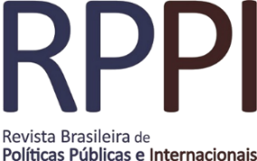

The Public Policy of Care to Victims of Domestic/Intrafamily Violence: The Social Representations of Public Network Professionals

A política pública de atendimento às vítimas da violência doméstica intrafamiliar as representações sociais dos profissionais da rede pública

Andeia de Costa
Karla Maria Damiano Teixeira
Ana Isabel Sani

DOI: [10.22478/ufpb.2525-5584.2022v7n2.57680]

Recebido em: 15/02/2021
Aprovado em: 14/09/2022

Abstract: The objective of this research was to understand the care provided to women and their children, victims of domestic and/or intrafamily violence, through the social representations of professionals in the public service network in the city of Viçosa/MG. Violence against women in the family environment is the result of a sexist and discriminatory culture, established over the years. This social and family phenomenon affects everyone involved in this context, especially women and their children. Thus, adolescents and children also become victims due to exposure to aggressions committed between their parents. To this end, 17 interviews were carried out with professionals who worked in three care institutions. The analysis of the lexical content was performed with the help of the IRaMuTeQ software. As a result, the terms woman, child, victims and violence appeared close, however, far from the terms linked to the actions provided by care institutions, such as policy, care, confrontation, law and resources. It is possible to conclude that the public policy to combat domestic/family violence needs to be restructured, through an integrated system between support institutions (health, justice, social assistance and education), so that implemented actions reach everyone involved and not discontinued before reaching their goals. The results presented constitute an advance for studies related to violence in the family environment and provide a basis for strengthening the Network to Combat Violence against Women, with support for both women/mothers and children and adolescents/children, who are also victims of that violence.

Resumo: O objetivo desta pesquisa foi compreender os atendimentos prestados às mulheres e aos seus filhos, vítimas da violência doméstica e/ou intrafamiliar, por meio das representações sociais dos profissionais da rede pública de atendimento no município de Viçosa/MG. As violências cometidas contra a mulher no ambiente familiar são práticas resultantes de uma cultura machista e discriminatória, estabelecida ao longo dos anos. Tal fenômeno social e familiar atinge todos os envolvidos neste contexto, principalmente mulheres e seus filhos. Assim, adolescentes e crianças também se tornam vítimas pela exposição às agressões cometidas entre seus pais. Para tanto, foram realizadas 17 entrevistas com profissionais que atuavam em três instituições de atendimento. Foi realizada a análise do conteúdo lexical com o auxílio do software IRaMuTeQ. Como resultado, os termos mulher, criança, vítimas e violências apareceram próximos, porém, distantes dos termos ligados às ações prestadas pelas instituições de atendimento, como política, atendimentos, enfrentamento, lei e recursos. Permite-se concluir que a política pública de enfrentamento a violência doméstica/familiar precisa ser reestruturada, por meio de um sistema integrado entre as instituições de apoio (saúde, justiça, assistência social e educação), para que ações implementadas atinjam todos envolvidos e não sejam descontinuadas antes de atingir seus objetivos. Os resultados apresentados constituem um avanço para os estudos relacionados à violência no ambiente familiar e fornecem base para o fortalecimento da Rede de Enfrentamento à Violência contra as Mulheres, com apoio tanto para as mulheres/mães como para crianças e adolescentes/filhos, que também são vítimas dessa violência.

Palavras-chave: violência doméstica; violência familiar; política pública; enfrentamento.

- Introduction
Domestic and family violence is a practice resulting from a sexist and discriminatory culture that has been established over the years. It is considered among the most serious problems faced by society and includes several practices, such as physical, emotional, psychological and verbal abuse, generating pain and fear for victims of aggression. Domestic and family violence is a practice resulting from a sexist and discriminatory culture that has been established over the years. It is considered among the most serious problems faced by society and includes several practices, such as physical, emotional, psychological and verbal abuse, generating pain and fear for victims of aggression. Children living in homes where violence is part of everyday life can experience the effects of violence in a variety of ways. They may learn the aggressive behaviors witnessed and/or develop emotional and cognitive problems.
In Brazil, as a way of preventing and restraining domestic and family violence, Law No. 11,340/2006 was created, known as the Maria da Penha Law, which started to consider domestic violence a specific crime. The Maria da Penha Law provides for integrated public policies between the responsible bodies, such as the operational integration of the Judiciary power, the Public Ministry and the Public Defender's Office, and areas of public security, social assistance, health, education, work and housing. The law aims to help women, victims of domestic violence, to rebuild their lives and recover from the trauma they have suffered.
In line with Law No. 11,340/2006, there is the National Policy to Combat Violence against Women, prepared by the Secretary of Policies for Women, with the purpose of establishing concepts, principles, guidelines and actions to prevent and combat violence against women, as well as assistance and guarantee of their rights. Therefore, networking arises with the objective of integrating the services in which the woman, in a situation of violence, goes through. Within the government, the Assistance Network for Women in Situations of Violence is composed of the following services: Reference Center for Care to Women; Centers for Assistance to Women; Shelters; Temporary Drop-in Centers; Specialized Women’s Police Stations (DEAMS); Nuclei or Care Centers for Women in Common Police Stations; Civil and Military Police; Legal medical Institute; Women's Defenders; Courts of Domestic and Family Violence; Women's Assistance Center – Call 180; ombudsmen; Women's Ombudsman of the Secretariat of Policies for Women; Health Services aimed at treating cases of sexual and domestic violence; Humanized Service Station at the Airports and Women's Center at Casa do Migrante (BRAZIL, 2011).
Recently, Law No.14,022/2020 was enacted, guaranteeing the uninterrupted care to victims of domestic/family violence, even in the presence of the pandemic caused by the coronavirus - COVID-19. Due to it, the situation of social isolation intensified the challenges experienced by women victims of violence in the domestic/family environment, who were forced to live longer with the aggressor. According to a digital data survey conducted by the Brazilian Forum on Public Safety (FBSP), reports of Intimate partner violence witnessed by neighbors increased by 431% between February and April 2020. Only in April, there was an increase of 53% in cases. Another aggravating factor indicated in the study is the dichotomy between the increase in cases of abuse and the decrease in denunciation, possibly explained by the difficulty found by victims to leave the house or fear, for being constantly with their partner.
Considering that the indication is that these women, in most cases, are assaulted in the family environment, concerns emerges with their children, kids and adolescents, exposed to these aggressions. The aggressive practices experienced can even model the aggressive behavior of a child. According to Sani, the child constructs meanings and representations of interparental violence from their experiences with incidents. In this context, the process of witnessing violence can contribute to a possible revictimization/perpetration in adulthood, denoted as “intergenerational transmission”, since it was something built throughout childhood and, inevitably, learned, which gives it a character of naturalization of violence.
Corroborating this understanding, the research conducted by Singulano and Teixeira, in which they analyzed the perception of adolescents about the cause of domestic and family violence against women, indicated the prevalence of opinions formulated from the personal experiences of adolescents, remaining the naturalization of violence against women and sexist values among adolescents, especially boys. The research indicated the need to invest in actions aimed at the primary prevention of violence.
In addition to the efforts of the State through the creation of laws to protect children and adolescents, studies are needed to ascertain, in practice, the situation of children of women who suffer domestic/family violence. Several areas, such as criminology, public health, sociology and psychology, have directed their studies to understand the complexity of family violence and contribute to the State creating strategies to combat family violence. Combat strategies must take into account the types of violent interactions, considering the profile of victims and aggressors and the stage of violence experienced.
Given this context, this study aimed to understand the care provided to women and their children, analyzing the representations of professionals who work in the public policy to combat domestic and family violence in the city of Viçosa/MG. As a theoretical contribution, we used the Program Theory to understand how interventions, projects, programs, strategies and initiatives of government assistance networks are being implemented to support victims.
- Development
2.1 Theoretical Framework
As a theoretical contribution, we used the Program Theory to understand the actions and results implemented by the public policy of care to victims of domestic and family violence in the city. Program Theory is seen as a framework of knowledge that bases, organizes, categorizes, describes and explains the functioning of programs, that is, the way in which the interventions were designed and intend to achieve the projected objectives. It is used to assess programs and public policies as a whole, both in terms of assessment aspects and in the analysis of information or diagnosis of results.
As components of the Program Theory, there are the Theory of Change and the Theory of Action. The first is related to the central process, guided by what is intended to change; an interpretation of how an intervention can lead to the desired results. On the other hand, the Theory of Action explains how programs or other interventions are constructed to activate the Theory of Change. Through them it is possible to determine the success or failures that may be occurring in the development of program activities, indicating aspects in which the program should be improved.
One of the ways to design and understand the Program Theory is through the use of Logical Models, a systematic and visual way of presenting and sharing the understanding of the relationships between the resources available for programmed actions and the changes or results expected to be achieved. One of the suggested logics is the differentiation of input, process, result and impact indicators.
In the research, we considered INPUTS, activities, products, results (OUTPUTS) and impacts. In the INPUTS we consider the physical structures and human resources, structured to assist victims of domestic/family violence. In the activities, we consider the direct activities, those linked to the program's beneficiaries, and the indirect ones, those necessary to guarantee the implementation of the policy. In the products, we consider the activities implemented, such as the number of children and adolescents assisted by the program, the number of hours of duration of an intervention, the number of trained professionals working in the program. In the results (OUTPUTS), we consider the changes observed after the implementation of the program, assessment of the efficacy, efficiency and effectiveness of the policy. Finally, regarding the impacts, we will assess whether there is intended social change.
2.2 Methodology
This exploratory-descriptive study used a quantitative-qualitative approach to describe and understand the care offered to women and children, victims of domestic and/or family violence. The population and sample universe consisted of professionals who worked in the assistance network for victims of domestic/intrafamily violence. The chosen context were three institutions that offer basic and special social-care assistance to these victims, namely: CREAS, Núcleo Mulher Viçosa and Military Police. CREAS is an institution that offers assistance, psychological and legal services to people violated in their rights. The Núcleo Mulher Viçosa is an institution created to expand the services offered to women victims of violence, with attributions focused on the reception and psychological, emotional and legal assistance. On the other hand, the Military Police is an institution that develops activities to protect victims, firstly promptly, in which they make the police report and take all protective measures. The institution also develops prevention work, through the Patrol for the Prevention of Domestic Violence (PPVD), in which those assisted women become part of the protection program, with the aim of restraining new practices of violence.
We collected the data from November 16 to 30, 2020, through interviews based on a semi-structured script, conducted virtually. At CREAS and at Núcleo Mulher Viçosa, the sample consisted of 12 professionals linked to psychosocial and legal assistance to victims, with 4 psychologists (3 from CREAS and 1 from Núcleo Mulher Viçosa); 5 social workers (3 from CREAS and 2 from Núcleo Mulher Viçosa); and 3 lawyers (2 from CREAS and 1 from Núcleo Mulher Viçosa). In the Military Police, the sample consisted of 5 professionals who work directly in the fight against domestic violence, indicated by the coordinator of the 10th Independent Military Police Company of Minas Gerais, with 1 lieutenant colonel (with coordination role in the confrontation policy); 1 corporal (who works on the elaboration of confrontation plans through occurrences); 3 military police officers with PPVD performance. The interviews followed the following themes: the diagnosis of the situation that demanded action; the actions and procedures adopted after the diagnosis; results achieved with the interventions; and, assessment of services.
We made simple and multivariate lexicographic analyzes and Descending Hierarchical Classification using the IRaMuTeQ software (Interface de R pour Iês Analyzes Multidimensionnelles de Textes et de Questionnaires). The software allowed the analysis through 4 graphic formats: the Class Dendrogram for Descending Hierarchical Classification (DHC); the Factor Map for Correspondence Factor Analysis (CFA); and the Maximum Similarity Tree and Tag Cloud.
At first, we conducted the statistical analysis using DHC. In this analysis, we separated the text segments into several vocabulary classes, in such a way that the highest possible values were obtained in a chi-squared test (X²). It was also possible to present the oppositions between the classes in the form of a dendrogram. The main frequencies of words favored the formation of representation. In a third moment, we conducted the Correspondence Factor Analysis (CFA), which allowed to visualize, in the form of a factorial plan, the oppositions resulting from the DHC, through the correlations between the variables, the lexicons with the highest frequencies and co-occurrences present in the speeches. We identified congruences and divergences within the belonging group.
The data obtained from the interviews and processed in the IRaMuTeQ software originated a corpus consisting of 725 Text Segmentos (STs), with an 84% utilization of the corpus content, which represented 609 STs subdivided in a hierarchical and descending manner into interconnected classes, forming categories and subcategories. We found 13,860 occurrences; 2,353 distinct word forms; 19.11, on average, of forms by segments. From the corpus analysis, we found 06 classes of representational content, each one linked to a descriptive or interventional aspect.
We used the similarity trees and tag clouds as graphs to represent the co-occurrence of terms and the similarity indices of the words that composed the Factor Map and the Class Dendogram. In the similitude trees, the circles and lines represent the importance and/or representativeness of the analyzed content. The line and distance between the circles indicate the strength of the link, the closer they are, the stronger the link. Another important information concerns the categorization of circles, which are united by some common characteristic, forming clusters. The identification of clusters is represented by different colors, providing a direct view of the connections.
2.3. Results and Discussion
The research aimed to understand the social representations of professionals about the care provided by the institutions where they worked. The representation in the form of a dendrogram (Figure 1) allowed to identify the existence or not of differences between the groups and the position that each group presented in relation to the care policy in the city. Analyzing the themes, it was possible to identify the existence of 02 blocks: general categories, composed by class 06, and another block, composed of classes 05, 04, 03, 01 and 02. In the organization of the classes, we made the categorization considering the frequency and percentage of distribution of each word in each class, considering the chi-squares measured. We divided and subdivided the classes into thematic axes and named according to the objective proposed by the research (Table 1).
Table 01: Dendrogram of thematic classes that emerged from the analysis of the interviews

DHC - 6 texts
609 STs

Group 01
Care policies overview
Group 02 - Assessment of implemented actions

Confrontation policy design
Confrontation strategies
Problem diagnosis

CLASS 6  71 STs  11,7% | CLASS 3  149STs  24,5% | CLASS 5  136  22,3% | CLASS 4  92 STs  15,1% | CLASS 1  91STs  14,9 | CLASS 2  70STs  11,5%
Politician  Resource  Confrotation  Model  Instrument  Law  Public  Protocol  Relationship  Formative  Policy  Failure  Opinion  System  Implement  Intrafamily  Intervention  Plan  Protection  Prevention  Protective  Domestic violence  Exposition  System  Implement  Intrafamily  Intervention  Plan  Protection | Achieve  Work  Psychological  Family  AccompanimentPsychologist  Care  Welcomed  Assistant  Receptive  Right  Institution  Young  Legal  Clinical  Program  CAPS  Act  Psychosocial  Improvement  Integral  Individual  Development  Adult  Process  Area  City  Feedback  Assistance | Something  Better  Situation  Training  Woman  Treatment  Dependence  Victimization  Help  Depend  Group  Session  Offer  Attend  Refined  Condition  Professional  Communication  Refuse  Financial  Need  Place  Cycle  Society  Job  Continue  Talk  Cease  Help | Mother  Child  Adolescent  Father  Witness  Behavior  School  Assault  Symptom  Reproduce  Experience  Challenge  Agressive  Speak  Exposition  Violence  Suffer  Son  Signal  Naturalize  Report  Episode  Develop  Domestic violence  Interparental  Technique | Agressor  Search  Woman  Son  Center  Cause  House  Victim  Frequency  CREAS  Environment  Violence  AccompanimentPriority  Risk  Relative  Partner  Local  Military  Man | Position  Receive  Child Protective Services  CREAS  Referral  Direct  Measure  Spontaneous  Send  Denunciation  Victim  Forum  Visit  House  Judiciary  Police  Crime  Author  Police Station  Demand  Report  Diverse  Protective  Change  Achieve  Woman  Call
Source: Authors' elaboration based on IRaMuTeQ software reports, 2020.

We notice that the initial corpus was divided into 02 groups, showing the vocables with the highest X² and the attribute-variables that contributed significantly. The first group was composed only by class 06, which brings a general approach to the professionals' perception of actions implemented by the care policy. By analyzing its position, it is possible to infer that there is a gap between class 06 and the other classes. In the second group, “assessment of implemented actions”, we obtained 05 thematic classes, which we subdivided into other categories. The first of them is represented by the thematic category “results obtained with the public policy of confrontation”, composed only by class 03. The second, “care policies design”, is composed by class 05 (expected actions and results) and by another branching (confrontation strategy). The “confrontation strategy” branch, in turn, is composed of class 04 (challenges to break the cycle of violence) and the “problem diagnosis” branch. The most interconnected ramifications were those composed by classes 01 and 02.
We can observe, from the construction of the dendrogram (Figure 1), the graphic representation of the Public Policy of Care to victims of domestic/family violence. The first step to construct a public policy, based on the Program Theory, is to have a well-defined problem to be faced, its objectives, target audience and expected changes. With this construction, it is possible to make the necessary actions to face the problem that demands providence. The analysis of the dendrogram is presented in the next section.
The CFA results (Figure 1) corroborated the DHC results. The total variance of the words was explained by the sum of the percentage values of the correlations emerged with the data processing, with a total of 84% of utilization of the corpus content, which demonstrates reliability of the statistical parameters and consistency of the responses. The words that are in the middle, intersection between the axes, are interpreted as the words that stood out, with more relevant content, in the common sense of the interviews. Words that, even belonging to other word classes, are closely linked to one of the themes.
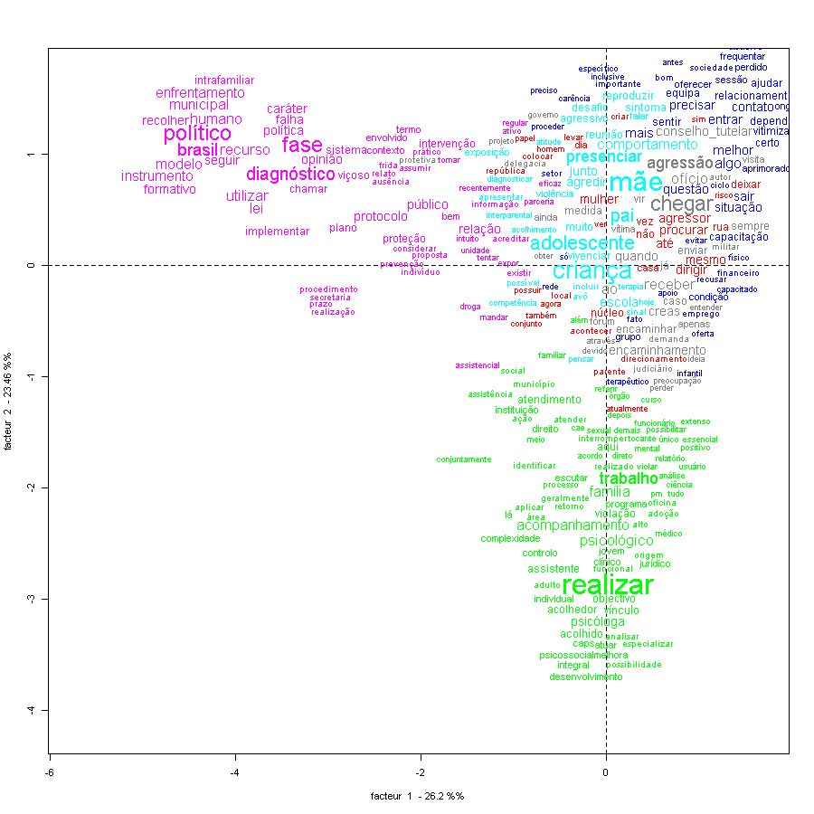
Figure 01: Correspondence Factor Analysis with the representation of the relationships Source: Authors' elaboration based on IRaMuTeQ software reports, 2020.

Class 6
Class 3
Class 5
Class 4
Class 2
Class 1

The CFA confirms and exemplifies the relationship among classes. From the analysis, we observe an approximation between classes 02, 04 and 05 and a distance between classes 03 and 06. When word classes tend to go to the ends, as in the case of class 06 (purple color) and 03 (green color), it means that the content they represent are distant. We believe that this distance is related to the notes made by the participants, who indicated a fragility in the actions implemented by the public policies of network care. According to the Theory of Change, one of the components of the Program Theory, the distant classes can be understood as central points that need to be reviewed, considering how an intervention can lead to the desired results. In order to confirm this hypothesis, it is important to conduct the similarity analysis, with the representation of similarity trees and tag clouds, which will be done next.
2.3.1 Care policies overview (Group 1)
Initially, in group 01, composed of class 06, we categorized the contents referring to the perceptions of the interviewees about the public policy to combat interparental violence. We obtained a utilization of 14.9% in DHC, with 91 STs. We systematized the words that represent this category in the similarity analysis and are presented in Figure 2.
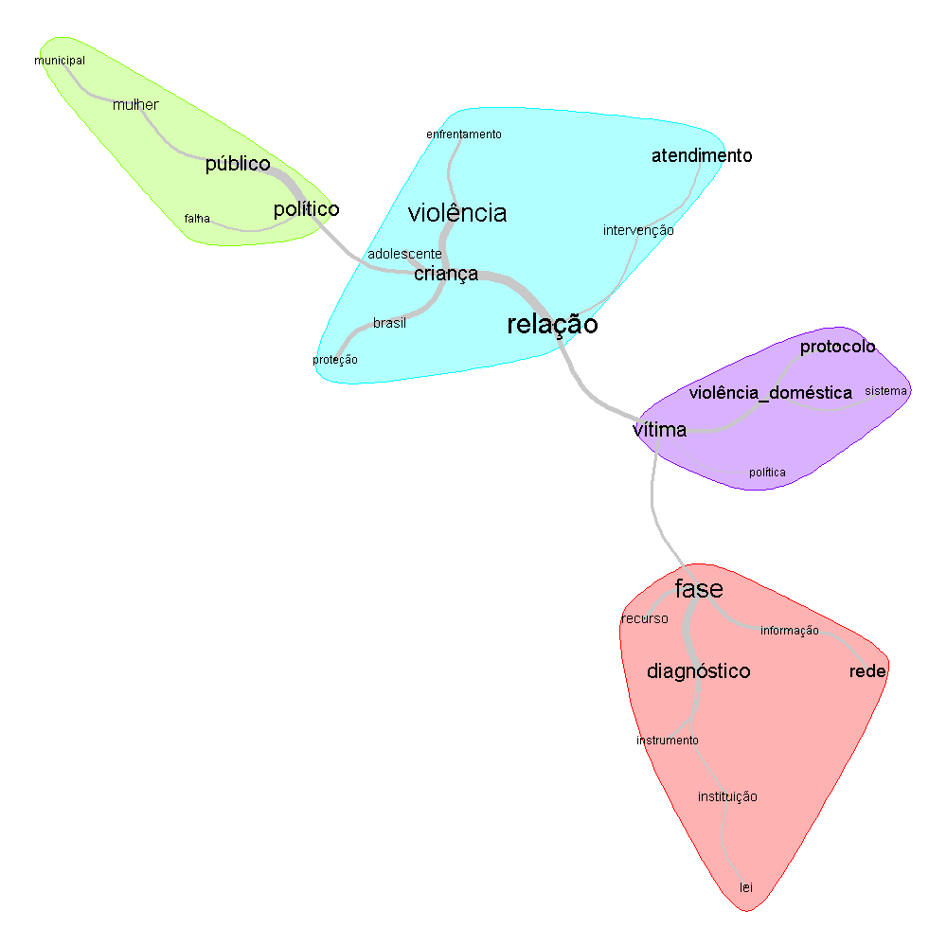
Figure 02: Similarity of words that indicate perceptions about the implemented actions.
Source: Authors' elaboration based on IRaMuTeQ software reports, 2020.

The result of the similarity analysis has brought indications of connectedness among the words, forming a co-occurrence tree, used to interpret the structure of representations. The results of this analysis, through the formed clusters, are close to the assessment, based on the Theory of Change: diagnosis phase (pink color); the actions and procedures adopted after diagnosis (lilac color); results achieved with the interventions (light blue color); and, assessment of services (green color). There is a gap between the groups formed, and the clusters of words are separated from each other and thin lines make the link between them. Only at some points there is a greater connection, with thicker lines. The weakest and most distant links indicate the points of public policy that need to be revised to reach the desired result. From this, we can infer that the actions implemented to assist victims of exposure to domestic/family violence have failures, demanding changes in their structure. The interview segments corroborate the results presented in Figure 2.
(...) need for a bill, I believe that if there is a law that makes interventions and protocols mandatory, the process works, in addition to charging responsibility by the institutions. (P15 - Lawyer - Núcleo Mulher Viçosa)
(...) even develop work with the aggressor, since the woman has the option of separating from her partner, but the child does not (...) (P16 – Psychologist – Núcleo Mulher Viçosa).
(...) it is necessary to revise the legislation on public policies, because like the law that governs the coordination, it has failures. (P 15 - Lawyer - Núcleo Mulher Viçosa)
(...) needs interaction with schools to learn out about the behavior of the child assisted, accompany for a certain time, report card, behavior, attendance, etc. (P4 - Psychologist - CREAS)

There is a need to implement actions in order to integrate education, health and social work professionals, forming an assistance network. The city's care policy presents difficulties in working with all those involved within the violent family context, especially regarding children and adolescents. State intervention is essential through effective public policies that focus on actions aimed at helping victims to overcome trauma and break the cycle. In relation to children and adolescents, programs and/or public policies must create actions that involve awareness and sensitization in schools and media, considering the influence of these spaces in adolescents’ lives.
2.3.2 Assessment of implemented actions (Group 2)
In the second group, categorized by the assessment of the implemented actions, we obtained 05 thematic classes, forming 02 groups (Figure 1). The first group was formed only by class 03, while the second contained classes 05, 04, 01, 02, which were subdivided into other categories. The tag cloud presented in Figure 3 shows the categorization and organization of vocables by the usage of their frequency.

Figure 03: Cloud of the occurrence of words within the assessment of actions
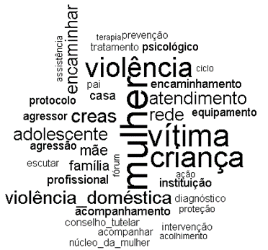
Source: Authors' elaboration based on IRaMuTeQ software reports, 2020.

In Figure 3, we observe that the words woman, victim, child and violence appear in the center of the figure, co-occurring with each other. The actions that must be implemented to work within a care policy appear at the ends of the figure: diagnosis, protection, reception, monitoring, listening, assistance, therapy. Based on the Program Theory, their distance from the words that appeared in the center may indicate failures in the execution of program activities. These results corroborate the previous ones, which indicated the need for improvement in the public policy of care to victims of domestic/family violence.
2.3.2.1 Public Policy of Confrontation
The group “public policy of confrontation”, formed only by class 03, presents the results obtained with the care policy, which had 24.5% of the STs retained in the DHC. Class 03 shows the results already obtained with the public policy of care in the city of Viçosa/MG, represented by the tag cloud in Figure 4.

Figure 04: Tag cloud about public policy of care
Source: Authors' elaboration based on IRaMuTeQ software reports, 2020.
The corpus indicates the services provided by the networks, and the most frequent words were: monitoring, work, family, psychologist, assistant, reception and care bond. The segments in this class highlight the actions, actors and intervention measures implemented with the objective of stopping any form of violation of rights and strengthening the family bond. The interviewees emphasized that the process of social readaptation is slow, considering that the family is an environment of privacy and that there is a lot of resistance, by the families, to continue with the planned interventions.
2.3.2.2 Care policy design
The group “care policy design” is represented by the category “care policy design”. In turn, this category is composed of class 05 (expected actions and results) and another branch (confrontation strategy), composed of class 04 (challenges to break the cycle of violence) and another branch (problem diagnosis). The most interconnected branch is composed of classes 01 and 02.
The results of the previous analyzes demonstrate the need to restructure the services, both regarding the beneficiaries of the policy and the execution of planned actions. The subjects' segments indicate failures in the care, such as: the lack of trained professionals; lack of physical structure; lack of family support involving victims and aggressors; lack of interaction with some care networks, pointing to a new intervention model, such as protective and preventive actions.
Based on the Theory of Change, activities that demand changes can be classified as direct or indirect. Direct activities are linked to the beneficiary of the program (woman/victim, child/adolescent/victim, man/aggressor), and indirect activities are those necessary to ensure the implementation of the policy. In direct activities, specialized and structured services are visualized in order to assist both women and children/adolescents, including, when possible, the man/aggressor, with the objective of creating mechanisms to overcome the effects of violence. On the other hand, indirect activities are aimed at training all professionals involved, so that they can work in a more specialized way with victims and the aggressor.
2.3.2.2.1 Expected actions and results
In Class 5, named expected actions and results, 22.3% of DHC STs were used. Figure 5 presents the tag cloud obtained for this class.
Figure 05: Tag cloud that deal with the expected actions and results.
Source: Authors' elaboration based on IRaMuTeQ software reports, 2020.

The words that stood out the most were: situation, contact, leave, training, victimization, treatment. Then, words that refer to necessary actions for the construction of more extensive and regular policies were highlighted, as expressed by the research subjects:
(...) function performed to support technicians to seek improvements for the equipment to promote better communication with the network (P7 - Social Worker - CREAS).
(...) the institution's functional objective to stop any form of violation of rights, strengthening the family bond of the target audience with the aim of promoting qualification and stopping the financial dependence of their aggressor partner and their child (P1 - Lawyer - CREAS).
In class 5, the subjects indicate measures they hope to achieve with a structured care policy: integration of support, health, justice, social work and education networks (CREAS, CRAS, WOMEN’S HOUSE AND SCHOOLS), training of professionals, promoting attention to the health (physical and psychological) of victims, developing work with families to combat forms of violence.
2.3.2.2.2 Confrontation strategies
The category “confrontation strategies” is a branch composed of classes 4, 1 and 2. The words that represent this category were systematized in the similarity analysis and justify the need for actions to assist children and adolescents, who live within a context of violence (Figure 6).
Figure 06: Similarity of word relationships within confrontation strategies
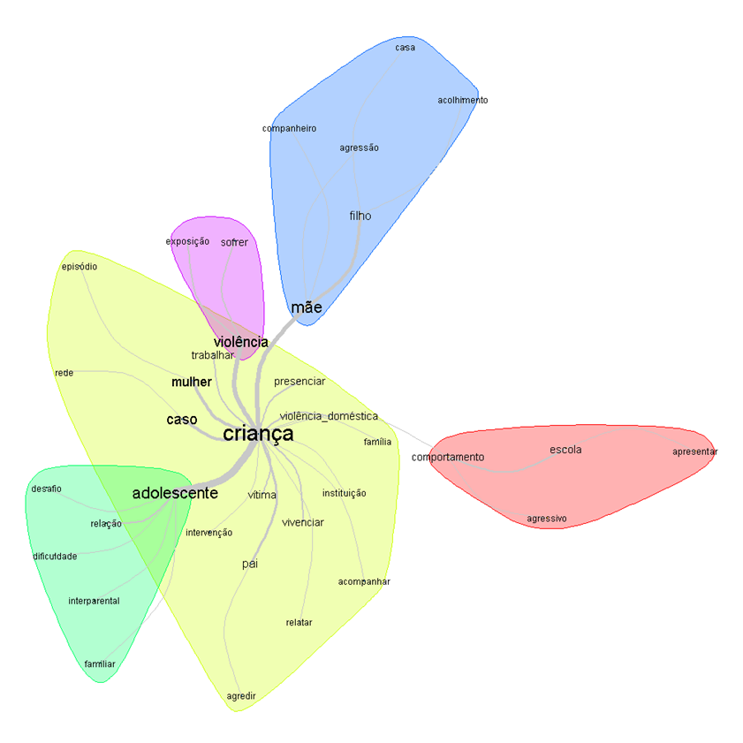
Source: Authors' elaboration based on IRaMuTeQ software reports, 2020.

In Figure 6, we observe that 05 clusters were formed. The cluster that stood out the most was the yellow one, in which the words child and adolescent appear in the center, interconnected with words in the same group, which refer to the family context in which they are involved: case, woman, violence, witnessing, domestic violence, witnessing, victim, intervention, accompany, among others. The word child also connects to the green, pink, blue, and purple clusters. We observe that the lines that connect the clusters become thinner and the most distant cluster is the pink one, composed of the words behavior, school, aggressive, present. According to Zhang e Banerju, the closer the clusters are, the stronger the link between them.
The result of the similarity analysis has brought indications of the need for structuring the care policy for the children of women victims of domestic/family violence. Studies have demonstrated that children who witness intimate partner violence face greater risks of developing anxiety, depression, low school performance, low self-esteem, nightmares, aggressive behavior and are more likely to suffer physical, sexual and emotional abuse in the short and long term. Therefore, this type of abuse should not be disregarded, but characterized as a growing public health problem. There is also the aggravation of re-victimization of family members affected by this violence, in case of remaining in the environment of aggression.
Thus, it really important that victims of witnessing violence are treated as victims of family abuse and maltreatment, which justifies the development of actions to combat the consequences of violence in their lives. These actions must be developed by multidisciplinary teams (educators, social workers, psychologists, lawyers, among others) to conduct tasks of assistance, prevention and fight against family violence.
Based on the analysis of confrontation strategies, we notice that there is awareness of the existence of crime due to exposure to domestic/intrafamily violence. However, there is no such policy officially, which justifies the improvement of the policy presented so that there is an integration within this context.
2.3.2.2.3 Problem diagnosis
The most interconnected branch, composed of classes 01 and 02, was named “problem diagnosis”. Figure 2 brings a relevant result for this branch, when it analyzes the words that compose the problem diagnosis cluster (pink color). We observe that the words diagnosis, resource, network, instrument, institution and law are interconnected by very thin lines, indicating failures in the problem diagnosis phase. In addition, the pink clusters are distant from the others.
From this analysis, it is possible to diagnose the problem: failures in care for victims of domestic and family violence. Demonstrating the need to improve the policy so that a set of actions is promoted to combat and prevent the effects of domestic violence on the lives of women and their children.
- Conclusion
This work aimed to study the services provided by the care institutions to women and their children. There is a weakness in the actions implemented by the public policy of network care, which compromises the process of assistance to direct and indirect victims of domestic and/or intrafamily violence.
Based on the Program Theory, we visualize the need for the actions of the care network for women/mothers and kids and adolescents/children to be developed in an integrated manner between the fields of health, education, social service, human rights and justice. Institutions, governmental and non-governmental services (such as schools, Military Police, CREAS, CAPS, Child Protective Services, school, Women’s House, society) must act in combatting the negative effects of violence. Therefore, it is important the connecting link in the stages of constructing public policies, from the diagnosis, construction of strategies to combat and prevention to the execution of actions, we visualize the need for joint work by the institutions.
The initial indicators of effectiveness of the axis justify the restructuring and/or improvement of the public policy to combat domestic and family violence, so that the implemented actions reach everyone involved and are not discontinued before reaching their goals We suggest to create an integrated system between the support network (health, justice, social work and education), so that they can include exposure to family violence in their activities; train professionals so that they can identify behavioral problems in children resulting from problems with their families; promote attention to health (physical and psychological) and to victims of witnessing family violence; and, develop work with families in order to combat and prevent forms of violence within the family space.

References
BRASIL. (2010). Lei Maria da Penha: Lei nº 11.340, de 7 de agosto de 2006, que dispõe sobre mecan0ismos para coibir a violência doméstica e familiar contra a mulher. Brasília: Câmara dos Deputados, Coordenação Edições Câmara, p. 34. [882143] CAM. Disponível: https://www2.camara.leg.br/legin/fed/lei/2006/lei-11340-7-agosto-2006-545133-norma-pl.html. Acesso: 10 nov. 2020.

________ Ministério da Cidadania. (2015). Centro de Referência Especializado de Assistência Social – CREAS. Brasília: DF.

________ (2014). Lei n. 13.431, de 13 de julho de 2017. Altera a Lei nº 8.069, de 13 de julho de 1990 (Estatuto da Criança e do Adolescente), para estabelecer o direito da criança e do adolescente de serem educados e cuidados sem o uso de castigos físicos ou de tratamento cruel ou degradante, e altera a Lei nº 9.394, de 20 de dezembro de 1996. Presidência da República. Brasília, DF. Disponível: http://www.planalto.gov.br/ccivil_03/_ato2015-2018/2017/lei/l13431.htm. Acesso: 20 abr. 2020.

________ Casa Civil da Presidência da República. (2018). Avaliação de Políticas Públicas – Guia Prática de Análise Ex Ante. Brasília, DF. Disponível: https://www.ipea.gov.br/portal/index.php?option=com_content&view=article&id=32688 Acesso: 20 out. 2020.

________ Senado Federal. (2020). CDH aprova monitoramento eletrônico de medidas protetivas da Lei Maria da Penha. Brasília, DF: Senado Federal. Disponível: https://www12.senado.leg.br/noticias/materias/2020/02/12/cdh-aprova-monitoramento-eletronico-de-medidas-protetivas-da-lei-maria-da-penha. Acesso: 11 dez.2020.

CAMARGO, B.V., & JUSTO, A.M. (2013). Tutorial para uso do software de análise textual IRAMUTEQ. Universidade Federal de Santa Catarina. Disponível: http://www.iramuteq.org/documentation/fichiers/tutoriel-en-portugais. Acesso: 10 dez.2020.

CARVALHO, M. M., FLEURY, A., & LOPES, A. P. (2013). An overview of the literature on technology roadmapping (TRM): contributions and trends. Technological Forecasting and Social Change, v. 80(7), pp. 1418-1437. Disponível: https://www.sciencedirect.com/science/article/abs/pii/S0040162512002934?via%3Dihub. Acesso: 05 jan. 2021.

CASSIOLATO, M., & GUERESI, S. (2010). Como elaborar Modelo Lógico. IPEA, Nota Técnica nº 6. Brasília, DF.

CLARKE, A., et al. (2020). Violence exposure and young people’s vulnerability, mental and physical health. International Journal of Public Health, v.65 pp. 357–366. Disponível: https://link.springer.com/article/10.1007/s00038-020-01340-3. Acesso: 09 nov.2020.

COUTO, P. L. S., et al. (2020). A presença do genitor no pré-natal: um estudo de representação sociais com gestantes. Rev. Enferm, UERJ, Rio de Janeiro, v.28. Disponível: https://www.e-publicacoes.uerj.br/index.php/enfermagemuerj/article/view/43407. Acesso: 07/12/2020.

COUTO, P. L.S., et al. (2018). Dilemmas and challenges for HIV prevention in repesentations of Young Catholics. Online braz. J. nurs, v. 17, n. 1, pp. 97-108. Disponível: http://www.objnursing.uff.br/index.php/nursing/article/view/5909. Acesso: 14 mar.2019.

ELIAS, N. Ü. Z. (1998). Frankfurt am Main: Suhkamp Taschenbuch Verlag, 1984. Sobre o tempo. Rio de Janeiro: Editora Jorge Zahar.

FÓRUM BRASILEIRO DE SEGURANÇA PÚBLICA (FBSP). (2020). Violência Doméstica Durante Pandemia de Covid-19. Disponível: https://forumseguranca.org.br/publicacoes_posts/violencia-domestica-durante-pandemia-de-covid-19/. Acesso: 09 dez.2020.

FREITAS, G., & SILVEIRA, S. F. R. (2015). Programa luz para todos: uma representação da teoria do programa por meio do modelo lógico. Planejamento de Políticas Públicas, n. 45, jul./dez. Disponível: file:///C:/Users/andre/Downloads/504-2057-1-PB.pdf. Acesso: 19 dez. 2020.

GODO, C. K., FREITAS, S. M. F., & CARVALHO, T. B. (2011). Motivação na Aprendizagem Organizacional: Construindo as Categorias Afetivas, Cognitivas e Social. ADM. MACKENZIE, v. 12, n. 2. São Paulo. Disponível: https://www.scielo.br/pdf/ram/v12n2/a03v12n2.pdf. Acesso: 08 mar. 2020.

HASSELLE, A.J., et al. (2020). 'Childhood Exposure to Partner Violence as a Moderator of Current Partner Violence and Negative Parenting', Violence Against Women, v.26 n.8, pp. 851–869. Disponível: https://journals.sagepub.com/doi/abs/10.1177/1077801219847291. Acesso: 04 dez.2020.

JUNUZZI, P. M. (2005). Indicadores para diagnóstico, monitoramento e avaliação de programas sociais no Brasil. Revista do Serviço Público, Brasília, v. 56, pp. 137-160, abr.- jun. Disponível: http://www.conei.sp.gov.br/ind/ind-sociais-revista-serv-publico.pdf. Acesso: 12 set. 2020.

LEAL, M. B. G., SOUZA, R., & CASTRO, A. C. D. (2015). Desenvolvimento Humano e teoria bioecológica: ensaio sobre “O contador de histórias”. Psicol. Esc. Educ, vol.19, n.2, Maringá. Disponível: https://www.scielo.br/scielo.php?script=sci_arttext&pid=S1413-85572015000200341&lng=pt&tlng=pt. Acesso: 28 mai. de 2020.

MADALENA, M., CARVALHO, L.F., & FALCKE, D. (2018). Violência conjugal: O poder preditivo das experiências na família de origem e das características patológicas da personalidade. Trends in Psychology, v. 26, n. 1, pp. 75-91. Disponível: http://pepsic.bvsalud.org/pdf/tp/v26n1/v26n1a04.pdf. Acesso: 22 nov. 2020.

MOREIRA, V. S., & SILVEIRA, S. F. R. (2018). Minha Casa, Minha Vida: Proposta de Avaliação com base na Teoria do Programa. RIGS Revista Interdisciplinar de Gestão Social, v.7, n. 1, jan-abri. Disponível: https://periodicos.ufba.br/index.php/rigs/article/view/24713. Acesso 23 nov, 2020.

ORR, C., et al. (2020). A Demographic Profile of Mothers and Their Children Who Are Victims of Family and Domestic Violence: Using Linked Police and Hospital Admissions Data. Journal of Interpersonal Violence. Disponível: https://journals.sagepub.com/doi/10.1177/0886260520916272. Acesso: 15 dez.2020.

PAIVA, T.T., PIMENTEL, C.E., & MOURA, G.B. (2017). Violência conjugal e suas relações com autoestima, personalidade e satisfação com a vida. Gerais: Revista Interinstitucional de Psicologia, v. 10, n. 2, pp. 215-227. Disponível: http://pepsic.bvsalud.org/scielo.php?script=sci_arttext&pid=S1983-82202017000200007. Acesso: 06 out.2020.

POLÍCIA MILITAR DE MINAS GERAIS. (2020). Violência Doméstica – Por Município. Armazém de Dados do CINDS/PMMG, Minas Gerais: PM. Nº PM 150.433-1. Disponível: https://intranet.policiamilitar.mg.gov.br/lite/assinador/web/validar?id=806944A259B7. Acesso: 10 nov.20.

VIÇOSA (MG). (2020). Núcleo Mulher Viçosa amplia o atendimento à mulheres na cidade. Disponível: https://www.vicosa.mg.gov.br/detalhe-da-materia/info/nucleo-mulher-vicosa-amplia-o-atendimento-a-mulheres-na-cidade/72147. Acesso: 04 dez.2020.

RIBEIRO, M.C.O., & SANI, A.I. (2008). As crenças de adolescentes sobre a violência interpessoal. Revista da Faculdade de Ciências Humanas e Sociais, v. 5, pp. 176-186. Disponível: http://hdl.handle.net/10284/909. Acesso 10 dez.2020.

RIBEIRO, A. (2015). Teoria de mudança: aplicações e aprendizados em uma experiência brasileira. Revista Brasileira de Avaliações, vol.9, pp. 4-15. Disponível: http://dx.doi.org/10.4322/rbma201509002. Acesso: 12 dez. 2020.

RIVAS, E., BONILLA, E., & VÁZQUEZ, JJ. (2020). Consequências da exposição a abusos na família de origem entre vítimas de violência praticada por parceiro íntimo na Nicarágua. American Journal of Orthopsychiatry, v. 90 n.1, pp. 1-8. Disponível: https://doi.apa.org/doiLanding?doi=10.1037%2Fort0000374. Acesso: 15 mar. 2020.

SANI, A. I. (2002). Crianças expostas à violência interparental. In C. Machado., & R. A. Gonçalves (Coords.), Violência e vítimas de crime, vol.2, pp. 95-131). Coimbra: Quarteto Editora.

SANI, A. I., & ALMEIDA, T. (2011). Violência interparental: a vitimação indireta de crianças. In A. I. Sani (Coord.), Temas de vitimologia: realidades emergentes na vitimação e respostas sociais. Edições Almedina, Coimbra, pp.11-32.

SHARPE, G. A. (2011). Review of Program Theory and Theory-Based Evaluations. American International Journal of Contemporary Research, v.1, n.3.

SILVA, S.A., et al. (2015). Análise da violência doméstica na saúde das mulheres. Revista Brasileira Crescimento e Desenvolvimento Humano. v.25, n.2, pp. 182-186. Disponível: https://www.revistas.usp.br/jhgd/article/view/103009. Acesso: 20 jan.2021.

SINGULANO, Y. L., & TEIXEIRA, K. M. D. (2020). Percepção de adolescentes sobre as causas da violência doméstica e familiar contra as mulheres. Oikos: Família E Sociedade Em Debate, v. 31, n. 1, pp. 96-118. Disponível: https://periodicos.ufv.br/oikos/article/view/8979. Acesso: 20 jan. 2021.

WAGNER, J., et al. (2019). Intergenerational Transmission of Domestic Violence: Practitioners' Perceptions and Experiences of Working with Adult Victims and Perpetrators in the UK: Practitioners' Perceptions of Domestic Abuse Transmission. Child Abuse Review, v. 34. pp. 577–588. Disponível: https://link.springer.com/article/10.1007%2Fs10896-018-0018-9. Acesso: 06 mai.2020.

WEISS, C. H. (1998). Evaluation: Methods for studying programs and policies. 2. New Jersey: Prentice Hall.

ZHANG, W., BANERJI, S. (2017). Challenges of servitization: A systematic literature review. Indusdustrial Marketing Management, v. 65, pp. 217-227. Disponível: https://www.yellowcats.nl/media/1531/challenges-of-servitization-industr-mark-mgt-meta-study-2017.pdf. Acesso: 15 dez. 2020.

ACKNOWLEDGMENT
The presented article is funded by CNPQ (National Council for Scientific and Technological Development). We take this opportunity to thank CNPQ for encouraging quality national public research.

Universidade Federal de Viçosa – E-mail: andreialannabrand@gmail.com.
Universidade Federal de Viçosa – E-mail: kdamiano@ufv.br.
E-mail: anasani@ufp.edu.pt.
SILVA, S.A. et al. Análise da violência doméstica na saúde das mulheres. Revista Brasileira Crescimento e Desenvolvimento Humano. v.25, n.2, pp. 182-186, 2015 Available at: https://www.revistas.usp.br/jhgd/article/view/103009. Access on: 20 jan.2021.
ORR, C., et al . (2020). A Demographic Profile of Mothers and Their Children Who Are Victims of Family and Domestic Violence: Using Linked Police and Hospital Admissions Data. Journal of Interpersonal Violence. Available at: https://journals.sagepub.com/doi/10.1177/0886260520916272. Access on: Dec 15th, 2020.
CLARKE, A. et al. Violence exposure and young people’s vulnerability, mental and physical health. International Journal of Public Health, v.65 p. 357–366, 2020. Available at: https://link.springer.com/article/10.1007/s00038-020-01340-3. Access on: 09 nov.2020.
RIVAS, E., BONILLA, E., & VÁZQUEZ, JJ. Consequências da exposição a abusos na família de origem entre vítimas de violência praticada por parceiro íntimo na Nicarágua. American Journal of Orthopsychiatry, v. 90 n.1, p. 1-8, 2020. Available at: https://doi.apa.org/doiLanding?doi=10.1037%2Fort0000374. Access on: Mar 15th, 2020.
HASSELLE, A.J et al. 'Childhood Exposure to Partner Violence as a Moderator of Current Partner Violence and Negative Parenting', Violence Against Women, v.26 n.8, p. 851–869, 2020 Available at: https://journals.sagepub.com/doi/abs/10.1177/1077801219847291. Access on: Dec 4th, 2020.
BRASIL, Lei Maria da Penha: Lei nº 11.340, de 7 de agosto de 2006, que dispõe sobre mecanismos para coibir a violência doméstica e familiar contra a mulher. Brasília: Câmara dos Deputados, Coordenação Edições Câmara, 2010. 34 p. [882143] CAM. Available at https://www2.camara.leg.br/legin/fed/lei/2006/lei-11340-7-agosto-2006-545133-norma-pl.html. Access on: Nov 10th, 2020.
BRASIL, Senado Federal. CDH aprova monitoramento eletrônico de medidas protetivas da Lei Maria da Penha. Brasília, DF: Senado Federal, 2020. Available at: https://www12.senado.leg.br/noticias/materias/2020/02/12/cdh-aprova-monitoramento-eletronico-de-medidas-protetivas-da-lei-maria-da-penha. Access on: Dec 11th, 2020.
FÓRUM BRASILEIRO DE SEGURANÇA PÚBLICA (FBSP). Violência Doméstica Durante Pandemia de Covid-19, 2020. Available at: https://forumseguranca.org.br/publicacoes_posts/violencia-domestica-durante-pandemia-de-covid-19/. Access on: Dec 9th, 2020.
ELIAS, N. Ü. Z. Frankfurt am Main: Suhkamp Taschenbuch Verlag, 1984. Sobre o tempo. Rio de Janeiro: Editora Jorge Zahar, 1998.
RIBEIRO, M.C.O.; SANI, A.I. As crenças de adolescentes sobre a violência interpessoal. Revista da Faculdade de Ciências Humanas e Sociais, v. 5, p. 176-186, 2008. Available at: http://hdl.handle.net/10284/909. Access on: Dec 10th, 2020.
GODO, C. K; FREITAS, S. M. F.; CARVALHO, T. B. Motivação na Aprendizagem Organizacional: Construindo as Categorias Afetivas, Cognitivas e Social. ADM. MACKENZIE, v. 12, n. 2. São Paulo, 2011. Available at: https://www.scielo.br/pdf/ram/v12n2/a03v12n2.pdf. Access on: Mar 8th, 2020.
LEAL, M. B. G.; SOUZA, R.; CASTRO, A. C. D. Desenvolvimento Humano e teoria bioecológica: ensaio sobre “O contador de histórias”. Psicol. Esc. Educ, vol.19, n.2, Maringá, 2015. Available at: https://www.scielo.br/scielo.php?script=sci_arttext&pid=S1413-85572015000200341&lng=pt&tlng=pt. Access on: May 28th, 2020.
SANI, A. I. Crianças expostas à violência interparental. In C. Machado & R. A. Gonçalves (Coords.), Violência e vítimas de crime, vol.2, p. 95-131). Coimbra: Quarteto Editora, 2002.
RIVAS, E., BONILLA, E., & VÁZQUEZ, JJ. Consequências da exposição a abusos na família de origem entre vítimas de violência praticada por parceiro íntimo na Nicarágua. American Journal of Orthopsychiatry, v. 90 n.1, p. 1-8, 2020. Available at: https://doi.apa.org/doiLanding?doi=10.1037%2Fort0000374. Access on: Mar 15th, 2020.
WAGNER, J.; JONES, S.; TSAROUCHA, A. & CUMBERS, H. Intergenerational Transmission of Domestic Violence: Practitioners' Perceptions and Experiences of Working with Adult Victims and Perpetrators in the UK: Practitioners' Perceptions of Domestic Abuse Transmission. Child Abuse Review, v. 34. p. 577–588, 2019. Available at: https://link.springer.com/article/10.1007%2Fs10896-018-0018-9. Access on: May 6th, 2020.
Singulano, Y. L., & Damiano Teixeira, K. M. (2020). Percepção de adolescentes sobre as causas da violência doméstica e familiar contra as mulheres. Oikos: Família E Sociedade Em Debate, 31(1), 96-118. Available at: https://periodicos.ufv.br/oikos/article/view/8979. Access on: Jan 20th, 2021.
SANI, A. I.; ALMEIDA, T. Violência interparental: a vitimação indireta de crianças. In A. I. Sani (Coord.), Temas de vitimologia: realidades emergentes na vitimação e respostas sociais. Edições Almedina, Coimbra, p.11-32, 2011.
MOREIRA, V. S.; SILVEIRA, S. F. R. Minha Casa, Minha Vida: Proposta de Avaliação com base na Teoria do Programa. RIGS Revista Interdisciplinar de Gestão Social, v.7, n. 1, jan-abri., 2018. Available at: https://periodicos.ufba.br/index.php/rigs/article/view/24713. Access on: Nov 23rd, 2020.
FREITAS, G.; SILVEIRA, S. F. R. Programa luz para todos: uma representação da teoria do programa por meio do modelo lógico. Planejamento de Políticas Públicas, n. 45, jul./dez, 2015. Available at: https://www.ipea.gov.br/ppp/index.php/PPP/article/view/504. Access on: Dec 19th, 2020.
WEISS, CAROL H. Evaluation: Methods for studying programs and policies. 2. New Jersey: Prentice Hall, 2.ed, 1998.
SHARPE, G. A. Review of Program Theory and Theory-Based Evaluations. American International Journal of Contemporary Research, v.1, n.3, nov.2011.
CASSIOLATO, M.; GUERESI, S. Como elaborar Modelo Lógico. IPEA, Nota Técnica nº 6. Brasília, DF. 2010.
JUNUZZI, P. M. Indicadores para diagnóstico, monitoramento e avaliação de programas sociais no Brasil. Revista do Serviço Público, Brasília, v. 56, p. 137-160, abr.- jun. 2005. Available at: http://www.conei.sp.gov.br/ind/ind-sociais-revista-serv-publico.pdf. Access on: Sep 12th, 2020.
BRASIL, Casa Civil da Presidência da República. Avaliação de Políticas Públicas – Guia Prática de Análise Ex Ante. Brasília, 2018. Available at: https://www.ipea.gov.br/portal/index.php?option=com_content&view=article&id=32688. Access on: Apr 22nd, 2020.
BRASIL, Ministério da Cidadania. Centro de Referência Especializado de Assistência Social – CREAS. Brasília: DF: Ministério da Cidadania, 2015.
VIÇOSA (MG). Núcleo Mulher Viçosa amplia o atendimento à mulheres na cidade, 2020. Available at: https://www.vicosa.mg.gov.br/detalhe-da-materia/info/nucleo-mulher-vicosa-amplia-o-atendimento-a-mulheres-na-cidade/72147. Access on: Dec 4th, 2020.
POLÍCIA MILITAR DE MINAS GERAIS. Violência Doméstica – Por Município. Armazém de Dados do CINDS/PMMG, Minas Gerais: PM, 2020. Nº PM 150.433-1. Available at: https://intranet.policiamilitar.mg.gov.br/lite/assinador/web/validar?id=806944A259B7. Access on: Nov 10th, 2020.
IRAMUTEQ (Interface de R pour les Analyses Multidimensionnelles de Textes et de Questionnaires), created by Pierre Ratinaud and maintained until 2009 in the French language. It currently has complete dictionaries in several languages. IRAMUTEQ is developed in the Python language and uses features provided by the statistical software R. They contribute to the dissemination of the various possibilities for processing qualitative data, since it allows different forms of statistical analysis of texts, produced from interviews, documents, among others. (CAMARGO & JUSTO, 2013).
COUTO, P. L.S.; PAIVA, M. S.; OLIVEIRA, J. F.; GOMES, A. M. T.; RODRIGUES, L. S. A.; TEIXEIRA, M. A. Dilemmas and challenges for HIV prevention in repesentations of Young Catholics. Online braz. J. nurs, v. 17, n. 1, p. 97-108, 2018. Available at: http://www.objnursing.uff.br/index.php/nursing/article/view/5909. Access on: Mar 14th, 2019.
COUTO, P. L. S; GOMES, A. M. T.; VILELA, A. B. A.; PEREIRA, S. S. C.; FRANÇA, L. C. M.; NOGUEIIRA, P. F. A presença do genitor no pré-natal: um estudo de representação sociais com gestantes. Rev. Enferm, UERJ, Rio de Janeiro, v.28, 2020. Available at: https://www.e-publicacoes.uerj.br/index.php/enfermagemuerj/article/view/43407. Access on: 12/07/2020.
The number of occurrences refers to the number of characters retained in the 84% of the corpus systematized in the DHC. Through the lemmatization process, the different occurrences are counted by the software in their reduced form, based on the stem corresponding to the word without inflection. Thus, the number of forms is smaller than the occurrence, since a reduced form can occur in the corpus in gender, number, degree, etc.
ZHANG, W.; BANERJI, SUJIT. Challenges of servitization: A systematic literature review. Indusdustrial Marketing Management, v. 65, p. 217-227, 2017. Available at: https://www.yellowcats.nl/media/1531/challenges-of-servitization-industr-mark-mgt-meta-study-2017.pdf. Access on: Dec 15th, 2020.
CARVALHO, M. M., FLEURY, A., & LOPES, A. P. An overview of the literature on technology roadmapping (TRM): contributions and trends. Technological Forecasting and Social Change, v. 80(7), p. 1418-1437, 2013. Available at: https://www.sciencedirect.com/science/article/abs/pii/S0040162512002934?via%3Dihub. Access on: Jan 5th, 2021.
CAMARGO, B.V; JUSTO, A.M. Tutorial para uso do software de análise textual IRAMUTEQ. Universidade Federal de Santa Catarina, 2013. Available at: http://www.iramuteq.org/documentation/fichiers/tutoriel-en-portugais. Access on: Dec 10th, 2020.
WEISS, CAROL H. Evaluation: Methods for studying programs and policies. 2. New Jersey: Prentice Hall, 2.ed, 1998.
SINGULANO, Y. L.; TEIXEIRA, K. M. D. (2020). Percepção de adolescentes sobre as causas da violência doméstica e familiar contra as mulheres. Oikos: Família E Sociedade Em Debate, 31(1), 96-118. Available at: https://periodicos.ufv.br/oikos/article/view/8979. Access on: Jan 20th, 2021.
SHARPE, G. A. Review of Program Theory and Theory-Based Evaluations. American International Journal of Contemporary Research, v.1, n.3, nov.2011.
RIBEIRO, A. Teoria de mudança: aplicações e aprendizados em uma experiência brasileira. Revista Brasileira de Avaliações, vol.9, p.4-15, 2015. Available at: http://dx.doi.org/10.4322/rbma201509002. Access on: Dec 12th, 2020.
ZHANG, W.; BANERJI, SUJIT. Challenges of servitization: A systematic literature review. Indusdustrial Marketing Management, v. 65, p. 217-227, 2017. Available at: https://www.yellowcats.nl/media/1531/challenges-of-servitization-industr-mark-mgt-meta-study-2017.pdf. Access on: Dec 15th, 2020.
MADALENA, M.; CARVALHO, L.F.; FALCKE, D. Violência conjugal: O poder preditivo das experiências na família de origem e das características patológicas da personalidade. Trends in Psychology, v. 26, n. 1, p. 75-91, 2018. Available at: http://pepsic.bvsalud.org/pdf/tp/v26n1/v26n1a04.pdf. Access on: Nov 22nd, 2020.
PAIVA, T.T.; PIMENTEL, C.E.; MOURA, G.B. Violência conjugal e suas relações com autoestima, personalidade e satisfação com a vida. Gerais: Revista Interinstitucional de Psicologia, v. 10, n. 2, p. 215-227, 2017. Available at: http://pepsic.bvsalud.org/scielo.php?script=sci_arttext&pid=S1983-82202017000200007. Access on: Oct 6th, 2020.

